

***the reviewer, copying or other use of this document or any of its content is strictly prohibited and may be unlawful.***

***The information in this document and any attachment(s) is confidential and may be legally privileged. If you are not***

**www.integrasi.com**

**Jakarta, 12920**

**Jl. Jend. Sudirman Kav. 22-23**

**Barclay House 1 9th Fl**

**PT. Integrasi Solutions**

Letter number: 217/P/IS/05/2010

Version: 1.0

Integrasi Solutions

Group Ajinomoto Indonesia

**Intranet Portal Project**



Page **2** of **48**

Link to Several Application.....................................................................................................19

Photo Gallery...........................................................................................................................19

Workflow / SOP Overview......................................................................................................19

Project Overview .....................................................................................................................19

FAQ’s ......................................................................................................................................19

Tasks........................................................................................................................................19

Calendar Event.........................................................................................................................19

Reservation..............................................................................................................................19

Message from the President / CEO..........................................................................................19

Thin Client File Server ............................................................................................................16

Workflow for Master Data.......................................................................................................16

Corporate Information Documents ..........................................................................................15

Corporate Announcement........................................................................................................15

Corporate News.......................................................................................................................15

5.2.14

5.2.13

5.2.12

5.2.11

5.2.10

5.2.9

5.2.8

5.2.7

5.2.6

5.2.5

5.2.4

5.2.3

5.2.2

5.2.1

Corporate or Department Functional List ..............................................................................................15

File Sharing Flow – Outbound.................................................................................................15

File Sharing Flow – Inbound ...................................................................................................14

Updating Intranet Content .......................................................................................................12

Workflow for Master Data (Add or Update) ...........................................................................12

5.2

5.1.4

5.1.3

5.1.2

5.1.1

Business Flow........................................................................................................................................11

5.1

Overall Design..................................................................................................................................................11

5

Exclude....................................................................................................................................10

Include .......................................................................................................................................9

4.4.2

4.4.1

Scope of Work .........................................................................................................................................9

Benefits....................................................................................................................................................9

Purpose of Solution..................................................................................................................................9

Project Scheme ..........................................................................................................................8

Functional..................................................................................................................................7

Environment ..............................................................................................................................7

4.4

4.3

4.2

4.1.3

4.1.2

4.1.1

Overview..................................................................................................................................................7

4.1

Executive Summary............................................................................................................................................7

4

Contact person .........................................................................................................................................6

3.1

Company Profile.................................................................................................................................................6

PUBLICATION DETAILS................................................................................................................................5

**DAFTAR ISI**

3

2

**1**

REVISION 1: FINAL RELEASE

1.0

STATUS

VERSION

CONFIDENTIAL

ARISTEJO

INTRANET PORTAL PROJECT

CLASSIFICATION

AUTHOR

TITLE

**INDONESIA**

**GROUP AJINOMOTO**



Page **3** of **48**

Natrindo Selular.......................................................................................................................42

Asuransi Tugu..........................................................................................................................40

Indosat .....................................................................................................................................39

Minamas Plantation .................................................................................................................37

Aneka Tambang.......................................................................................................................34

7.2.5

7.2.4

7.2.3

7.2.2

7.2.1

Project Experience .................................................................................................................................34

Special Achievement ...............................................................................................................33

Company profile......................................................................................................................33

Company Address....................................................................................................................33

7.2

7.1.3

7.1.2

7.1.1

Company Overview ...............................................................................................................................33

7.1

Appendix ..........................................................................................................................................................33

7

Maintenance Cost ....................................................................................................................32

Implementation Cost................................................................................................................32

6.5.2

6.5.1

Quotation................................................................................................................................................32

6.5

Maintenance Scheme...............................................................................................................32

Deliverables By Project ...........................................................................................................32

Deliverables By SDLC ............................................................................................................31

Deliverables By Phase.............................................................................................................31

6.4.4

6.4.3

6.4.2

6.4.1

Project Deliverables...............................................................................................................................31

6.4

Administrator Training............................................................................................................30

User Training...........................................................................................................................30

6.3.2

6.3.1

User Training .........................................................................................................................................30

Methodology..........................................................................................................................................27

Phase 2.....................................................................................................................................26

Phase 1.....................................................................................................................................26

6.3

6.2

6.1.2

6.1.1

Project Schedule.....................................................................................................................................26

6.1

Project Management.........................................................................................................................................26

6

System Constrain.....................................................................................................................25

System Architecture Diagram..................................................................................................23

Network Diagram ....................................................................................................................22

5.3.3

5.3.2

5.3.1

System Diagram.....................................................................................................................................22

Minimum Requirement............................................................................................................21

Technical Specification............................................................................................................21

Intranet Portal Site Map...........................................................................................................21

Features....................................................................................................................................20

Reporting .................................................................................................................................20

5.3

5.2.19

5.2.18

5.2.17

5.2.16

5.2.15

REVISION 1: FINAL RELEASE

1.0

STATUS

VERSION

CONFIDENTIAL

ARISTEJO

INTRANET PORTAL PROJECT

CLASSIFICATION

AUTHOR

TITLE

**INDONESIA**

**GROUP AJINOMOTO**



Page **4** of **48**

Scope of Works Assumptions................................................................................................................48

Resources Assumptions .........................................................................................................................48

PROJECT MANAGEMENT ASSUMPTIONS ....................................................................................48

8.3

8.2

8.1

Asumpsions ......................................................................................................................................................48

8

Integrated with Ultimus Inbox (Future Development).............................................................47

Report ......................................................................................................................................46

Department Homepage ............................................................................................................46

Corporate Homepage...............................................................................................................45

7.4.4

7.4.3

7.4.2

7.4.1

Sample Screen Shots and Report Images...............................................................................................45

7.4

Job Description........................................................................................................................44

Curriculum Vitae Of Project Leader........................................................................................43

Project Organization................................................................................................................43

7.3.3

7.3.2

7.3.1

project Staffing.......................................................................................................................................43

7.3

REVISION 1: FINAL RELEASE

1.0

STATUS

VERSION

CONFIDENTIAL

ARISTEJO

INTRANET PORTAL PROJECT

CLASSIFICATION

AUTHOR

TITLE

**INDONESIA**

**GROUP AJINOMOTO**



Page **5** of **48**

Integrasi Solutions

Aristejo

Best Regards

copy, reference should be made to the Document Owner for verification.

This document is stored and maintained electronically. If any doubt exists as to the issue status of a printed

Revision 1: Final Release

**REMARKS**

Aristejo

**REVISED BY**

**CREATED /**

25 June 2010

**REVISION DATE**

**CREATION /**

1.0

**VERSION**

: Confidential

: Group Ajinomoto Indonesia

: Intranet Portal Project

: 217/P/IS/05/2010

Security Classification

Subject Classification

Document Title

Document Refference

**DOCUMENT CONTROL RECORD**

outside of PT. Integrasi Solutions or be used for purposes other than evaluation of Integrasi capabilities.

information and the ideas herein SHALL NOT be duplicated or disclosed in whole or in part to anyone

provide assistance to PT. Integrasi Solutions in response to the inquiry of **Group Ajinomoto Indonesia**. The

ideas, and concepts contained herein are to be used exclusively to evaluate the capabilities of Integrasi and to

This proposal contains confidential material proprietary to PT. Integrasi Solutions (Integrasi). The material,

**CONFIDENTIALITY DISCLOSURE STATEMENT**

**PUBLICATION DETAILS**

**2**

REVISION 1: FINAL RELEASE

1.0

STATUS

VERSION

CONFIDENTIAL

ARISTEJO

INTRANET PORTAL PROJECT

CLASSIFICATION

AUTHOR

TITLE

**INDONESIA**

**GROUP AJINOMOTO**

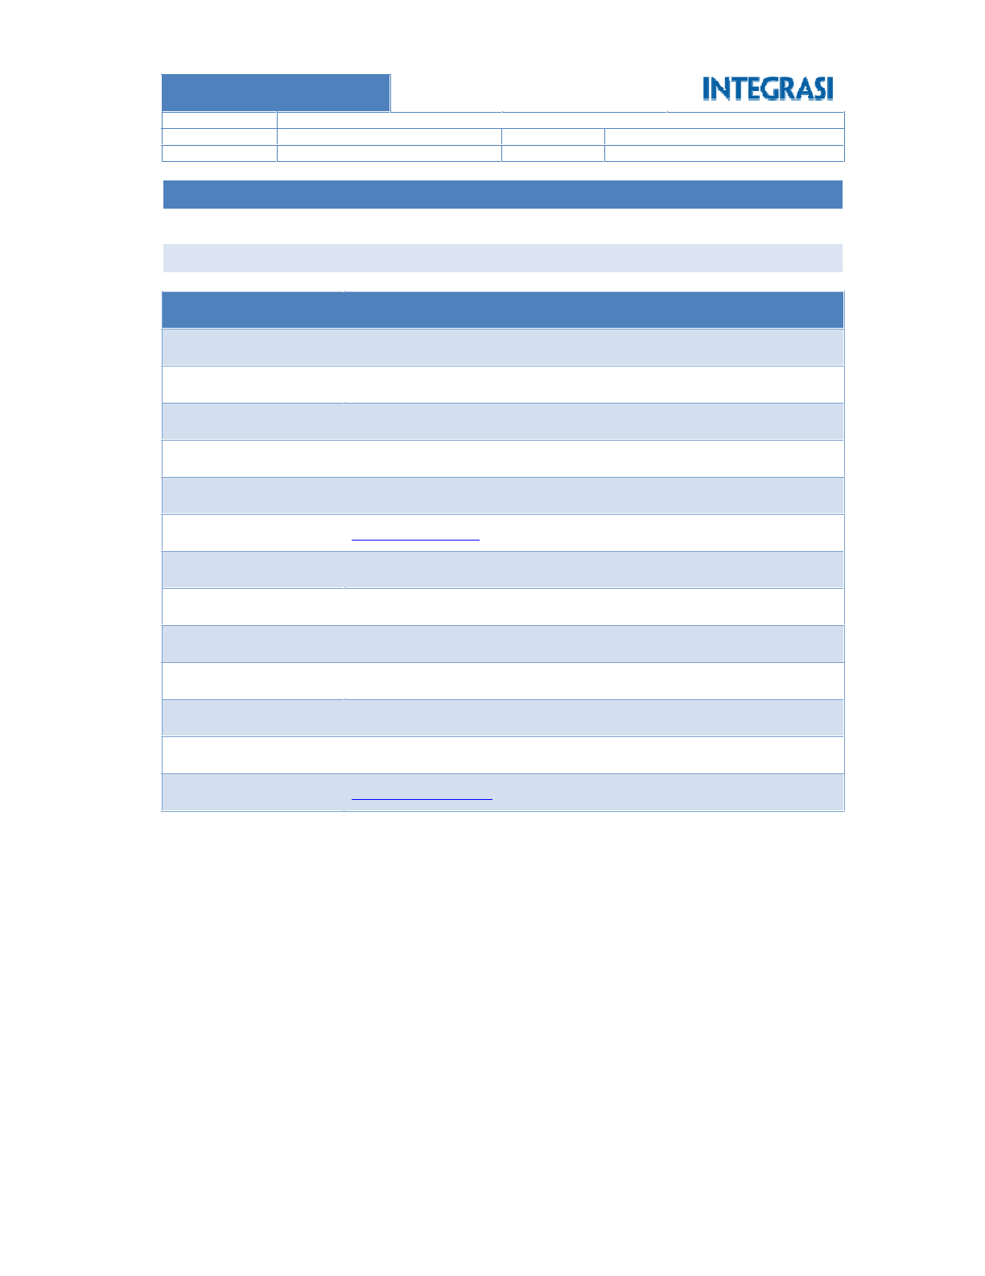

Page **6** of **48**

aristejo@integrasi.com

021-5711002

021-5711400 ext 635

Barclay’s House I 9th Fl Jl. Jend. Sudirman Kav. 22 – 23 (d/h Wisma BCA)

Solution Architect

Aristejo

**Email**

**Fax**

**Phone**

**Address**

**Position**

**Name**

rinnu@integrasi.com

021-5711002

021-5711400

Barclay’s House I 9th Fl Jl. Jend. Sudirman Kav. 22 – 23 (d/h Wisma BCA)

Account Manager

Rinnu Hidayati

**Email**

**Fax**

**Phone**

**Address**

**Position**

**Name**

**Contact Person**

CONTACT PERSON

3.1

**COMPANY PROFILE**

**3**

REVISION 1: FINAL RELEASE

1.0

STATUS

VERSION

CONFIDENTIAL

ARISTEJO

INTRANET PORTAL PROJECT

CLASSIFICATION

AUTHOR

TITLE

**INDONESIA**

**GROUP AJINOMOTO**

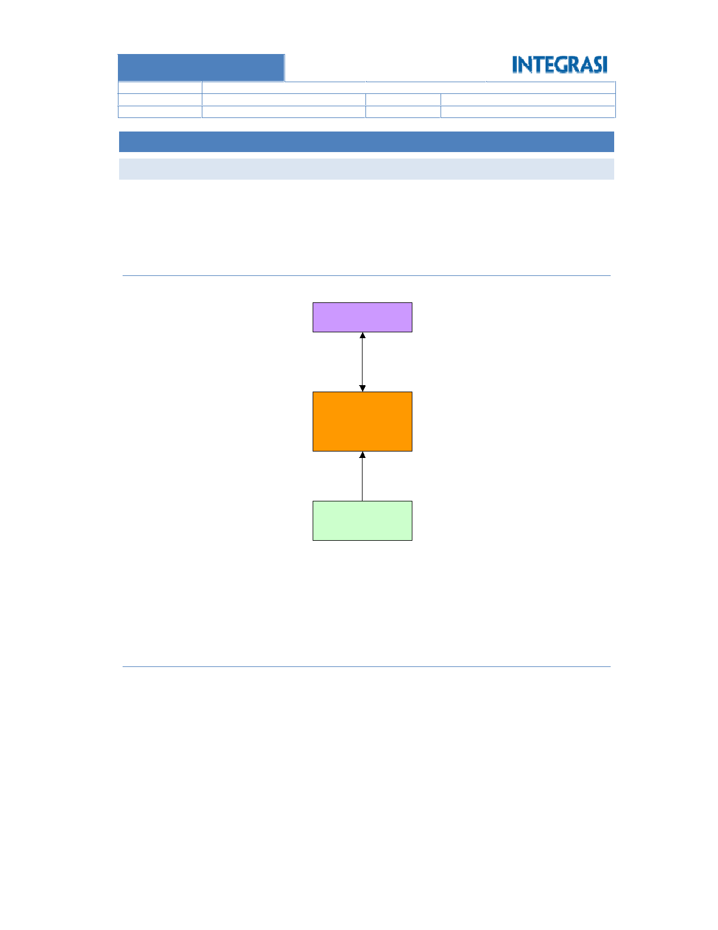

Page **7** of **48**

Search phone number extension

Thin client file server

Workflow for master data

Corporate announcements

Corporate news

Corporate information document

Booking LCD and notebook

Booking meeting room

















Intranet Portal should consist functional as follows:

Functional

4.1.2

be save / upload, and retrieve / download.

storage to store file. Thsese files will be manage and display through Intranet Portal. File management should

Intranet portal will retrieve user identity (username, email, and password) from active directory. File server is

There are 2 major entities related with Intranet Portal; Active Directory, and File Server.

Active Directory

Intranet Portal

File Server

Environment

4.1.1

New Intranet Portal will solve those problems.

document because it is not accompanied by an adequate system.

reservation. Its also quite defficult for each department to add r update sharing corporate information

Current intranet is now has many problems especially interms of LCD, notebook, and meeting room

OVERVIEW

**EXECUTIVE SUMMARY**

4.1

**4**

REVISION 1: FINAL RELEASE

1.0

STATUS

VERSION

CONFIDENTIAL

ARISTEJO

INTRANET PORTAL PROJECT

CLASSIFICATION

AUTHOR

TITLE

**INDONESIA**

**GROUP AJINOMOTO**

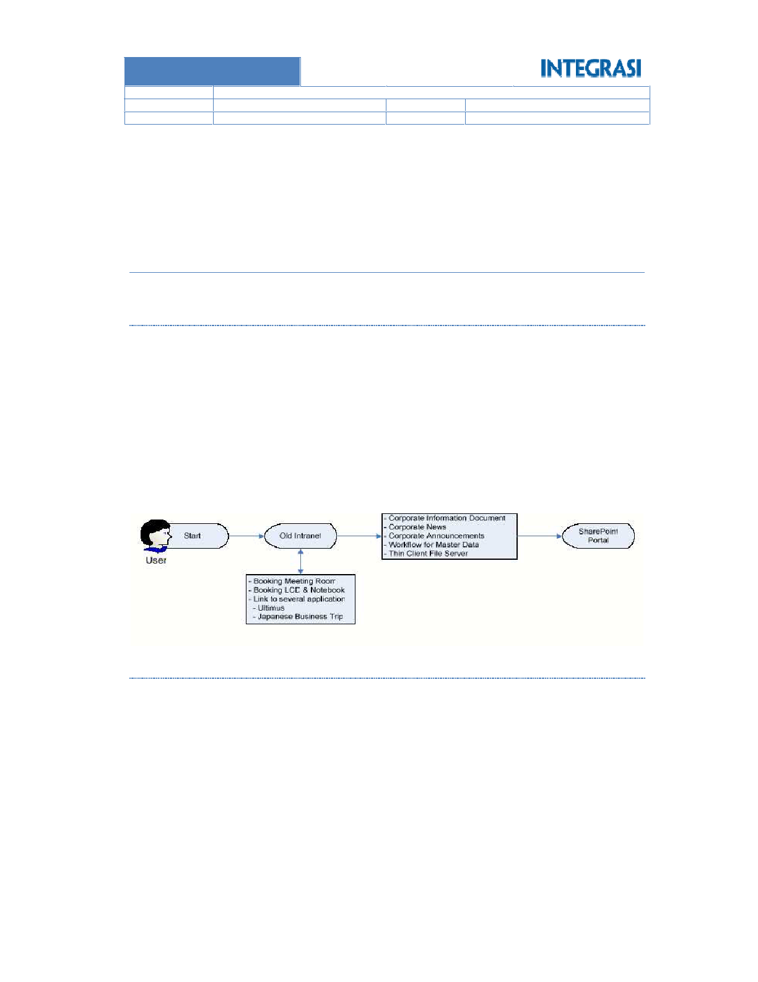

Page **8** of **48**

Reporting

Photo gallery

Workflow / SOP overview

Projects overview

FAQ’s

Tasks

Calendar event

LCD, notebook, and meeting room reservation

Message from the President / CEO



















Delivery on this phase is consists as follows:

4.1.3.2 Phase 2

Link to new intranet portal in old one should be developed by Ajinomoto.

several applications. Hyperlink will be used to linking old intranet with new one.

Ajinomoto will still use the old intranet portal for LCD, notebook and meeting room reservation and link to

Thin client file server

Workflow for master data

Corporate information documents

Corporate announcements

Corporate news











Delivery on this phase is consists as follows:

4.1.3.1 Phase 1

Project will be running in 2 phase.

Project Scheme

4.1.3

Reporting

Link to several web application

Department home page

Search file and documents

Corporate president message











REVISION 1: FINAL RELEASE

1.0

STATUS

VERSION

CONFIDENTIAL

ARISTEJO

INTRANET PORTAL PROJECT

CLASSIFICATION

AUTHOR

TITLE

**INDONESIA**

**GROUP AJINOMOTO**

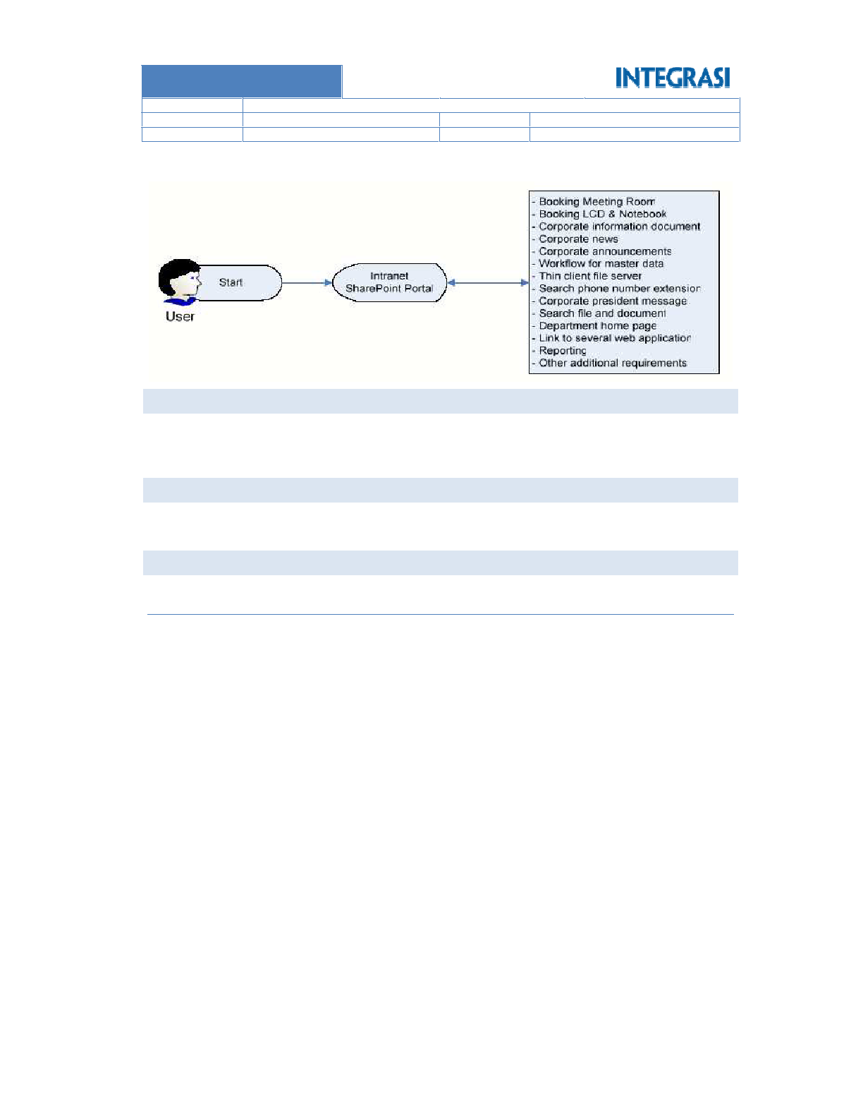

Page **9** of **48**





o File server report

o Project activity report

o View page report

o Meeting room reservation

o Notebook reservation

o LCD Reservation

Building report:

o Meeting room reservation

o Notebook reservation

o LCD Reservation

o File sharing

o Master data (add and update)

o Update content

Building workflow for:

o Link to applications. Assumption: 5 applications

o Photo Gallery

o Project Overview

o FAQ’s

o Task

o Calendar event

o Message from President / CEO

o Corporate announcement

o Corporate news

o Depeartment homepage

Building Intranet Portal using Sharepoint framework:

Include

SCOPE OF WORK



4.4.1

4.4

Securing sharing file server

Support corporate daily work activities

BENEFITS





4.3

 Reservation: LCD, notebook, and meeting room

 Sharing corporate information documents

The purpose on the Intranet portal is as follows:

PURPOSE OF SOLUTION

4.2

In this phase, intranet is fully operated by sharepoint portal. Old intranet will be demoted.

REVISION 1: FINAL RELEASE

1.0

STATUS

VERSION

CONFIDENTIAL

ARISTEJO

INTRANET PORTAL PROJECT

CLASSIFICATION

AUTHOR

TITLE

**INDONESIA**

**GROUP AJINOMOTO**



Page **10** of **48**

Perform installation and traning for any locations outside JABODETABEK.

Perform installation more than locations that written in this proposal.

Providing, installation, and setting of operating system, database, and any other applications.

Providing server, network, and any other licenses

Providing, installation and setting for hardware (server, network, etc.).

Exclude











4.4.2

REVISION 1: FINAL RELEASE

1.0

STATUS

VERSION

CONFIDENTIAL

ARISTEJO

INTRANET PORTAL PROJECT

CLASSIFICATION

AUTHOR

TITLE

**INDONESIA**

**GROUP AJINOMOTO**

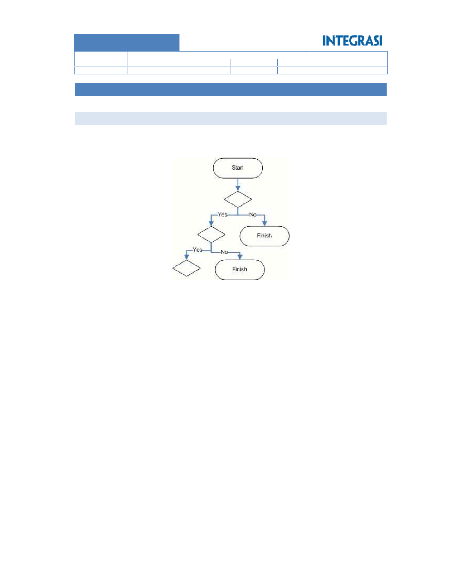

Page **11** of **48**

user must repeat the process to reach approved status.

methode in sharepoint, therefore whenever reject has derived then process will be void with notification and

All forms in workflow will use infopath. All workflow development will use waterfall methode as standard

BUSINESS FLOW

5.1

Intranet Portal will develop using Sharepoint technology.

**OVERALL DESIGN**

**5**

REVISION 1: FINAL RELEASE

1.0

STATUS

VERSION

CONFIDENTIAL

ARISTEJO

INTRANET PORTAL PROJECT

CLASSIFICATION

AUTHOR

TITLE

**INDONESIA**

**GROUP AJINOMOTO**

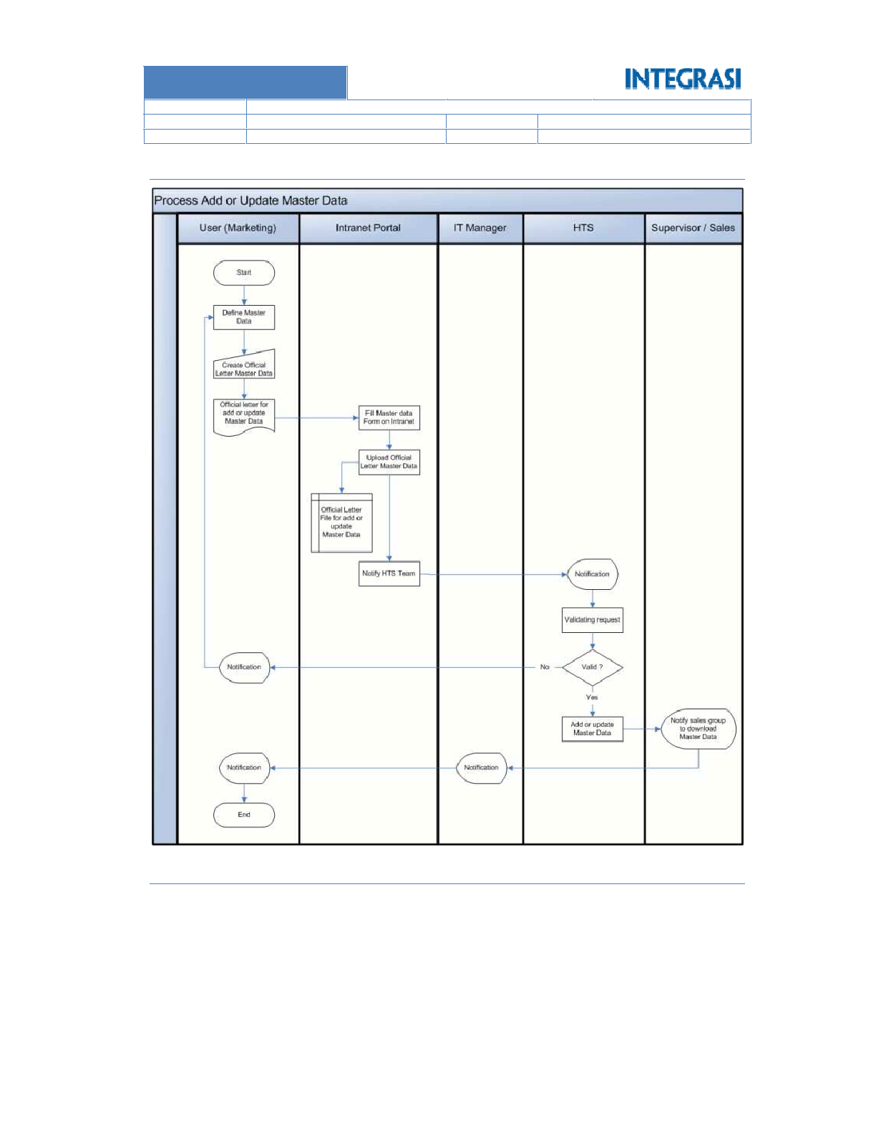

Page **12** of **48**

Operation Procedure (SOP) to be performed is as follows:

There are some rules that must be executed by the user if they want to do updates on the intranet. Standard

Updating Intranet Content

5.1.2

Workflow for Master Data (Add or Update)

5.1.1

REVISION 1: FINAL RELEASE

1.0

STATUS

VERSION

CONFIDENTIAL

ARISTEJO

INTRANET PORTAL PROJECT

CLASSIFICATION

AUTHOR

TITLE

**INDONESIA**

**GROUP AJINOMOTO**

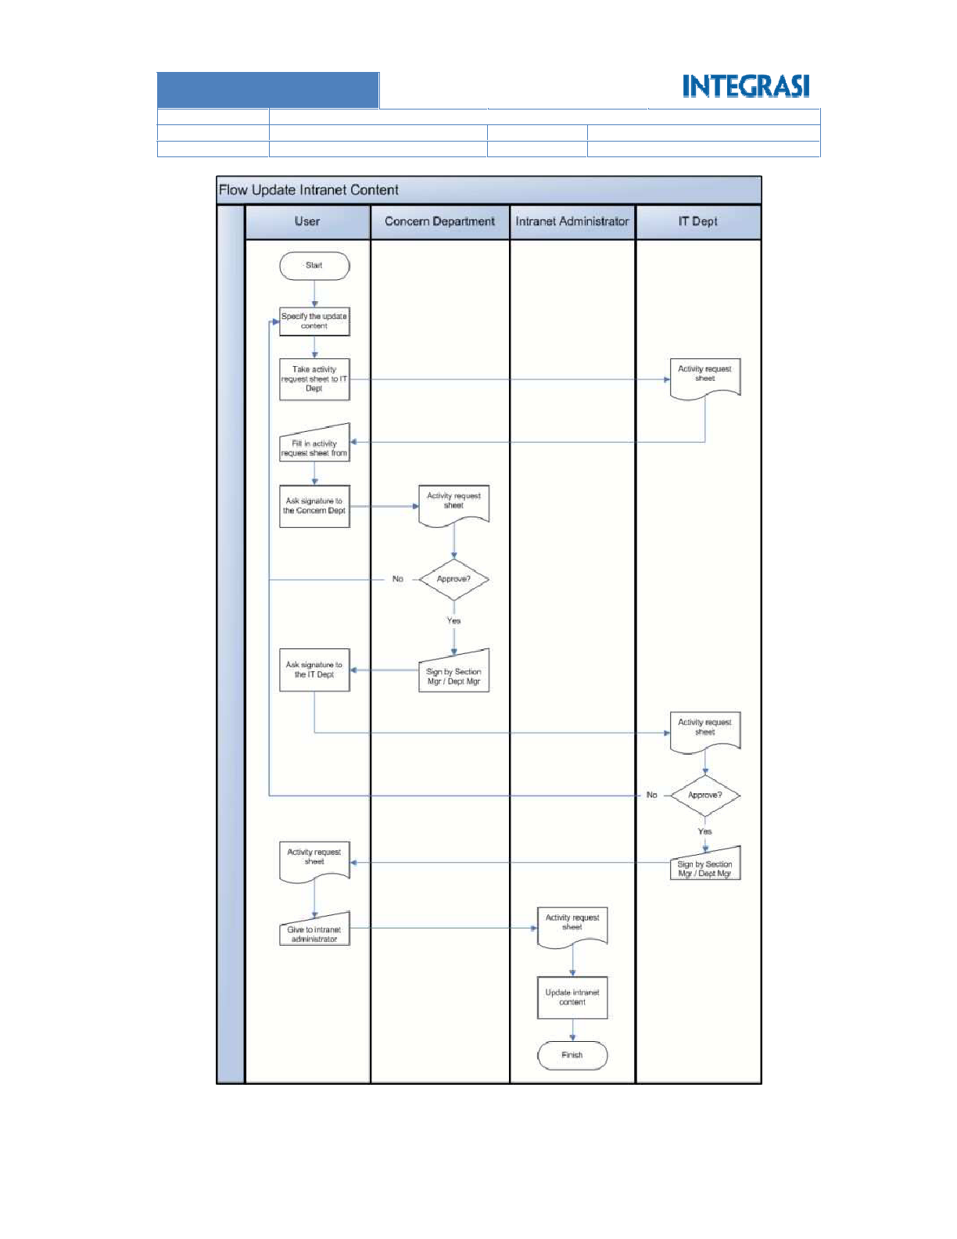

Page **13** of **48**

REVISION 1: FINAL RELEASE

1.0

STATUS

VERSION

CONFIDENTIAL

ARISTEJO

INTRANET PORTAL PROJECT

CLASSIFICATION

AUTHOR

TITLE

**INDONESIA**

**GROUP AJINOMOTO**

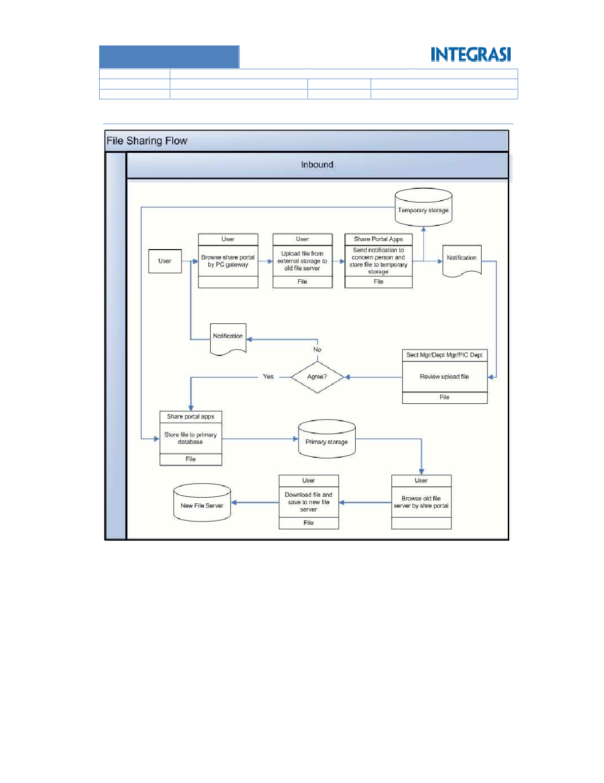

Page **14** of **48**

File Sharing Flow – Inbound

5.1.3

REVISION 1: FINAL RELEASE

1.0

STATUS

VERSION

CONFIDENTIAL

ARISTEJO

INTRANET PORTAL PROJECT

CLASSIFICATION

AUTHOR

TITLE

**INDONESIA**

**GROUP AJINOMOTO**

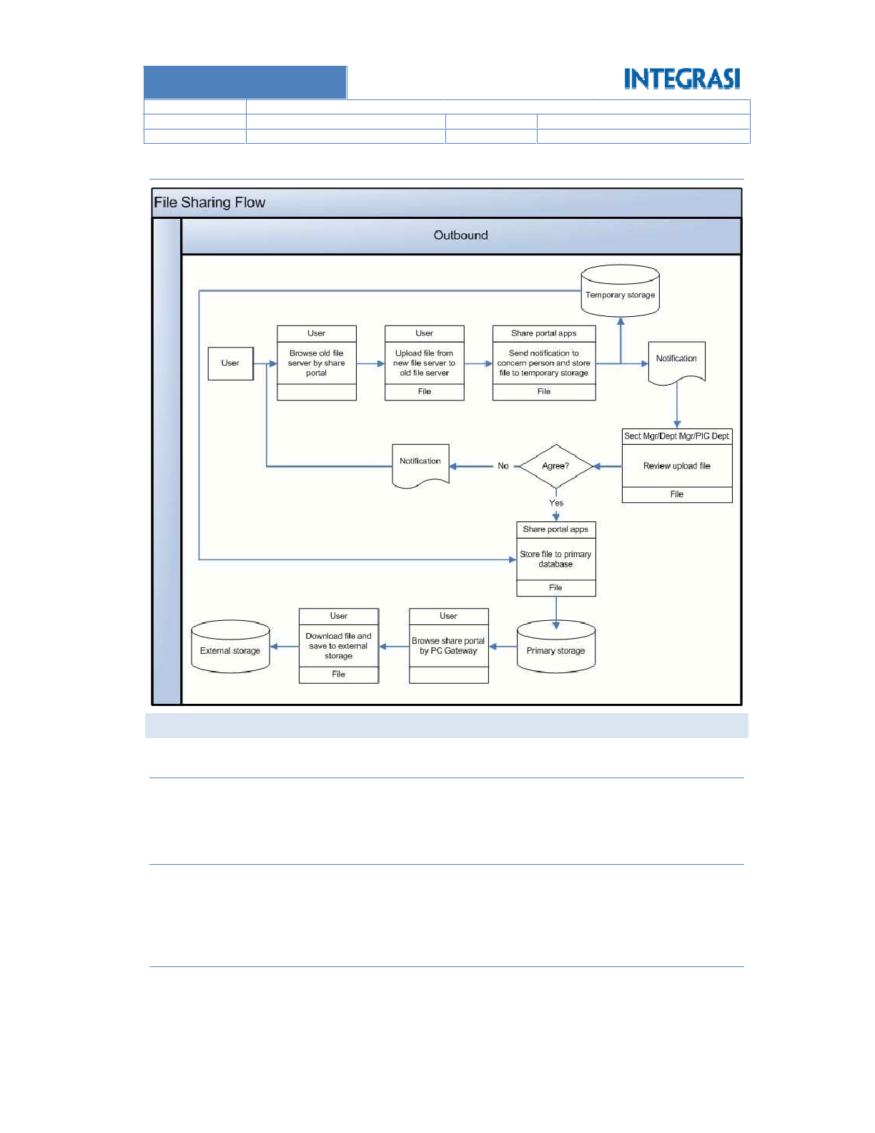

Page **15** of **48**

activity on the internal corporate.

leave form, and other corporate documents to help employee understand about documents that used in daily

Each department in GAI can share corporate informational documents such as working calendar, claim form,

Corporate Information Documents

5.2.3

This function is using standard sharepoint feature. It can be updated through sharepoint CMS.

spread rapidly.

Corporate or Department can create and give announcements to all intranet users so that the information can

Corporate Announcement

5.2.2

This function is using standard sharepoint feature. It can be updated through sharepoint CMS.

Corporate or Department can share the latest news to all users.

Corporate News

CORPORATE OR DEPARTMENT FUNCTIONAL LIST

5.2.1

5.2

File Sharing Flow – Outbound

5.1.4

REVISION 1: FINAL RELEASE

1.0

STATUS

VERSION

CONFIDENTIAL

ARISTEJO

INTRANET PORTAL PROJECT

CLASSIFICATION

AUTHOR

TITLE

**INDONESIA**

**GROUP AJINOMOTO**



Page **16** of **48**

Concept that will be implemented on Intranet Portal Ajinomoto is as follows:

5.2.5.1 Inbound

All fomrs in this function need infopath forms.

password same as in active directory.

This function is used to access thin client file server. To access this function, user must fill in username and

Thin Client File Server

5.2.5

All fomrs in this function need infopath forms.

updating master data to S6, Handy Terminal and SAP system.

Workflow for master data is used to help marketing department to synchronize and make addition or

Workflow for Master Data

5.2.4

This function is using standard sharepoint feature. It can be updated through sharepoint CMS.

REVISION 1: FINAL RELEASE

1.0

STATUS

VERSION

CONFIDENTIAL

ARISTEJO

INTRANET PORTAL PROJECT

CLASSIFICATION

AUTHOR

TITLE

**INDONESIA**

**GROUP AJINOMOTO**

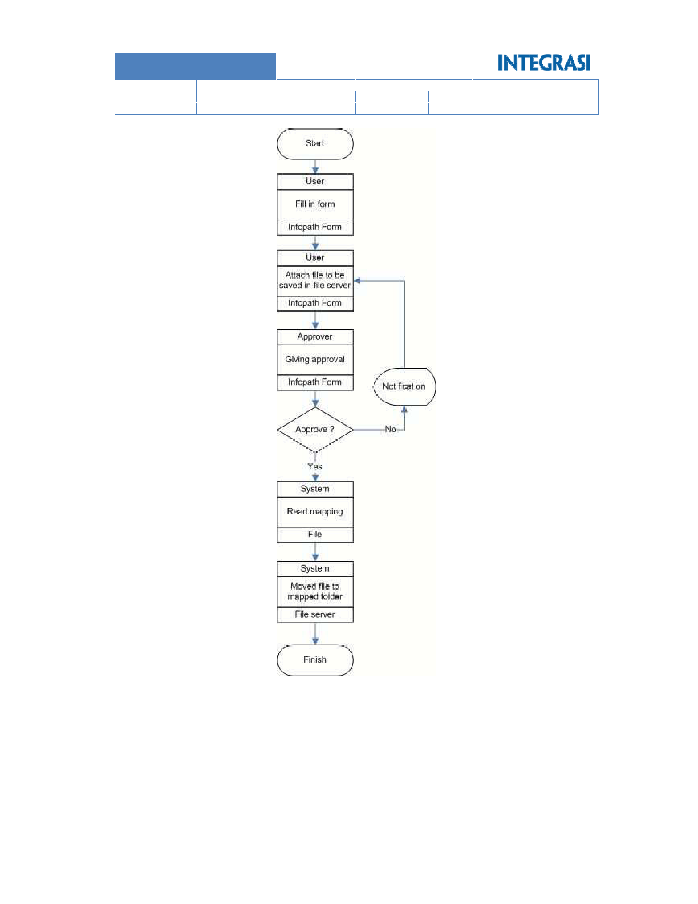

Page **17** of **48**

Therefore the process will be more efficient.

All files should be attached on infopath form before reach approval process.

Base on the concept, all approved files will be directly written to File Server and not using temporary storage.

REVISION 1: FINAL RELEASE

1.0

STATUS

VERSION

CONFIDENTIAL

ARISTEJO

INTRANET PORTAL PROJECT

CLASSIFICATION

AUTHOR

TITLE

**INDONESIA**

**GROUP AJINOMOTO**

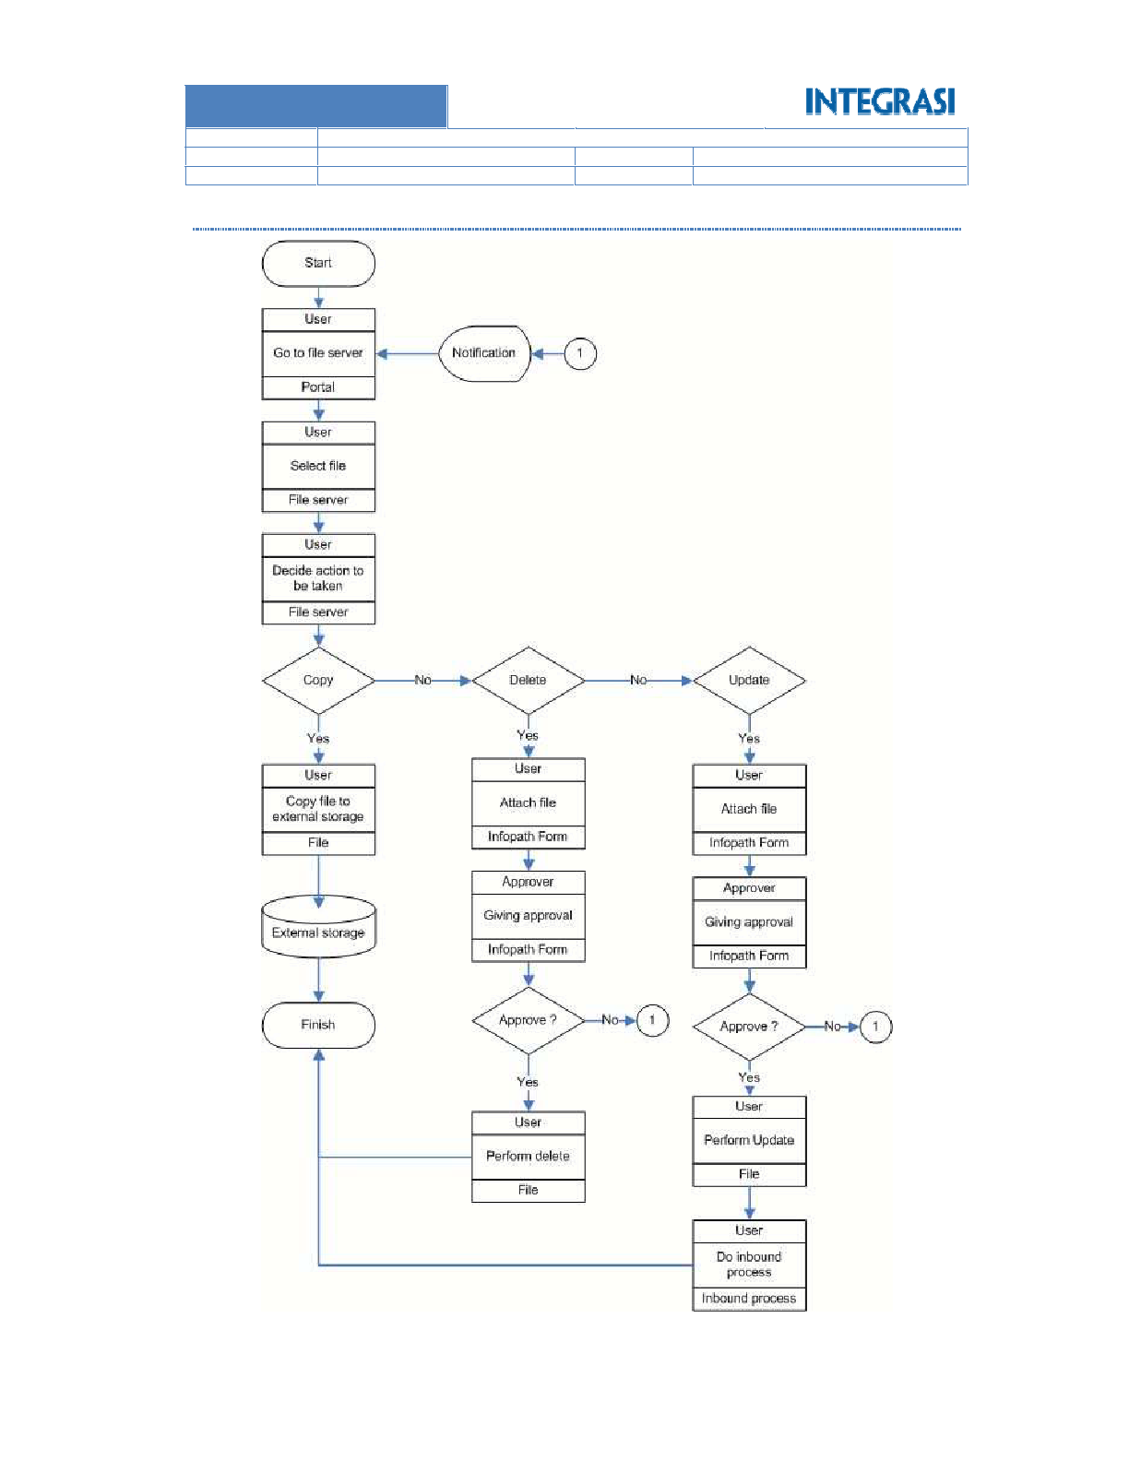

Page **18** of **48**

5.2.5.2 Outbound

REVISION 1: FINAL RELEASE

1.0

STATUS

VERSION

CONFIDENTIAL

ARISTEJO

INTRANET PORTAL PROJECT

CLASSIFICATION

AUTHOR

TITLE

**INDONESIA**

**GROUP AJINOMOTO**



Page **19** of **48**

like portal in portal.

application. Then, whenever the links has clicked, it will be showed up on portal interface. The ilustration is

There are 5 browsers applications. They want to be hosted in sharepoint servers. There will be a link to each

5.2.14 Link to Several Application

This function is using standard sharepoint feature. It can be updated through sharepoint CMS.

This function is required to displaying photos, pictures, and movies as well.

5.2.13 Photo Gallery

This function is using standard sharepoint feature. It can be updated through sharepoint CMS.

existing in internal corporate.

This function is required to help employee to understand about how Standard Operation Procedure (SOP)

5.2.12 Workflow / SOP Overview

This function is using standard sharepoint feature. It can be updated through sharepoint CMS.

Indonesia.

This function gives user information about the currently running project status on Group Ajinomoto

5.2.11 Project Overview

This function is using standard sharepoint feature. It can be updated through sharepoint CMS.

in some context, and pertaining to a particular topic.

Frequently Asked Questions or FAQ’s are listed questions and answers, all supposed to be frequently asked

5.2.10 FAQ’s

This function is using standard sharepoint feature. It can be updated through sharepoint CMS.

Corporate or Department can create and give a job lists to the users.

Tasks

5.2.9

standard sharepoint feature. It can be updated through sharepoint CMS.

Every activity on the booked meeting room will be displayed on the calendar event. This function is using

Calendar Event

5.2.8

this function need infopath forms.

This function is used to book LCD, notebook and meeting room to help daily activity in GAI. All fomrs in

Reservation

5.2.7

sharepoint feature. It can be updated through sharepoint CMS.

Corporate President/ CEO can share his speech through this function. This function is using standard

Message from the President / CEO

5.2.6

to placing back file ti its place.

users want to delete an update. Whenever update is complete then users need to perform the inbound process

because all user has their permission already by having access to file server. Approval still needed whenever

There are 3 types of action in outbound process: copy, update, and delete. For copy, no approval needed at all

REVISION 1: FINAL RELEASE

1.0

STATUS

VERSION

CONFIDENTIAL

ARISTEJO

INTRANET PORTAL PROJECT

CLASSIFICATION

AUTHOR

TITLE

**INDONESIA**

**GROUP AJINOMOTO**



Page **20** of **48**

Gallery that can contain photos, movies, etc.

Tasks for each users

Mapping to file server

Link to other applications

Upload and download

Workflow using bundled sharepoint workflow engine

User Access Management

Content Management System (CMS) using sharepoint CMS

Searching

Information board

Working calendar

Able to integrated with Ultimus (future development)

























5.2.16 Features

Report display: tabular and graph

Max quantity of reports: 8 reports

Page view / visitor

Accessing file server

Meeting room reservation

Notebook reservation

LCD reservation















Report Type:

Reporting model: static report

document report, page viewed report and other additional report based on vendor proposal.

Portal. Some report that we require like LCD, notebook and meeting room reservation report, shared

This function is required to help management understand about the situation and performance of Intranet

5.2.15 Reporting

The link should be using single VPN in intranet network.

REVISION 1: FINAL RELEASE

1.0

STATUS

VERSION

CONFIDENTIAL

ARISTEJO

INTRANET PORTAL PROJECT

CLASSIFICATION

AUTHOR

TITLE

**INDONESIA**

**GROUP AJINOMOTO**

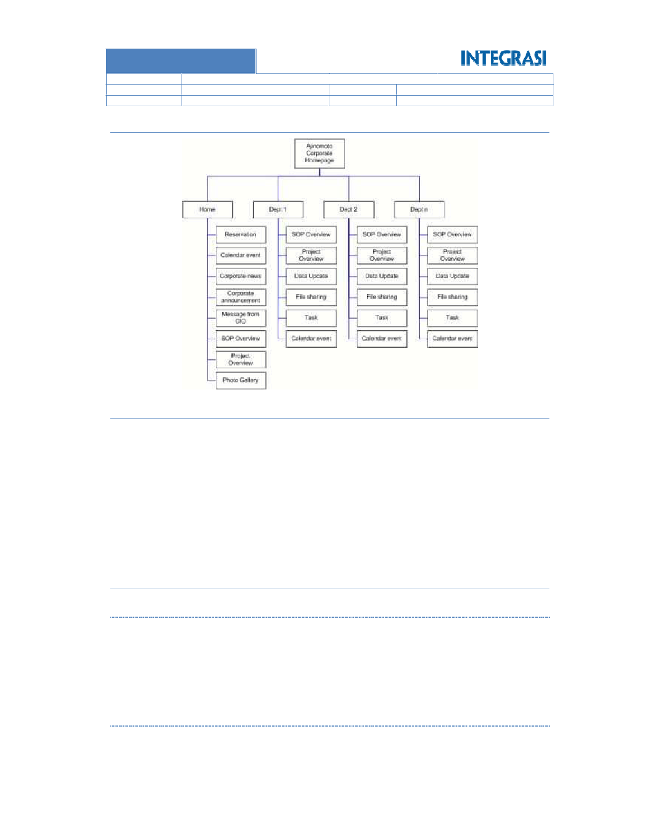

Page **21** of **48**

: Microsoft Info Path 2010 for Sharepoint 2010 / Infopath 2007 for Sharepoint 2007

: SQL Server 2008

: IIS

: IE 7.0

Web Browser

5.2.19.2 Client

Application

Database

Web Service

Sharepoint 2007.

: Windows Server 2008 R2 64bit (x64) for Sharepoint 2010 / Windows Server 2003 for

O/S

5.2.19.1 Server

5.2.19 Minimum Requirement

Windows Server 2003 R2 Enterprise Edition with SP2 32bit for Sharepoint 2007

Windows Server 2008 R2 64bit (x64) for Sharepoint 2010

o

o

O/S – Server

Database

Framework

:

: SQL Server 2008

: .NET 2.0 / 3.0

Or Microsoft Sharepoint 2007 to be supported by 32bit processor

Microsoft Sharepoint 2010. Please note that it only supported by 64bit processor.

:







o

o

Platform



5.2.18 Technical Specification

5.2.17 Intranet Portal Site Map

REVISION 1: FINAL RELEASE

1.0

STATUS

VERSION

CONFIDENTIAL

ARISTEJO

INTRANET PORTAL PROJECT

CLASSIFICATION

AUTHOR

TITLE

**INDONESIA**

**GROUP AJINOMOTO**

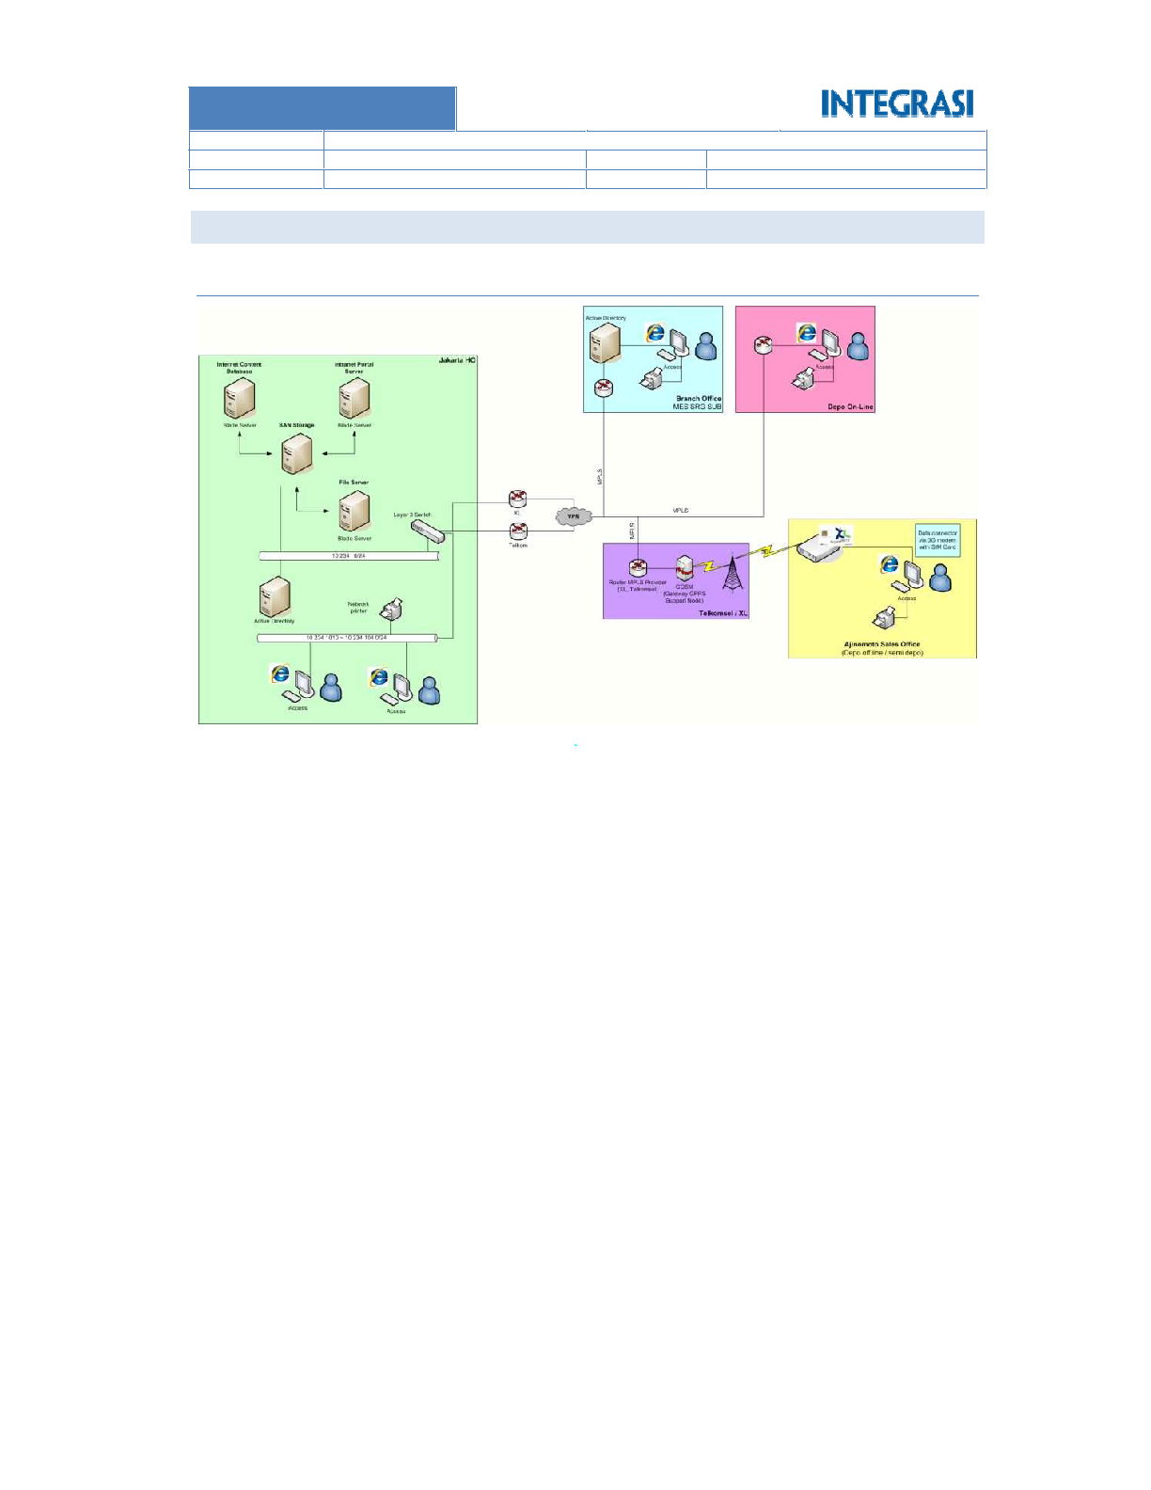

Page **22** of **48**

Minimum bandwidht requirement: 64 KBps

Network Diagram

SYSTEM DIAGRAM

5.3.1

5.3

REVISION 1: FINAL RELEASE

1.0

STATUS

VERSION

CONFIDENTIAL

ARISTEJO

INTRANET PORTAL PROJECT

CLASSIFICATION

AUTHOR

TITLE

**INDONESIA**

**GROUP AJINOMOTO**

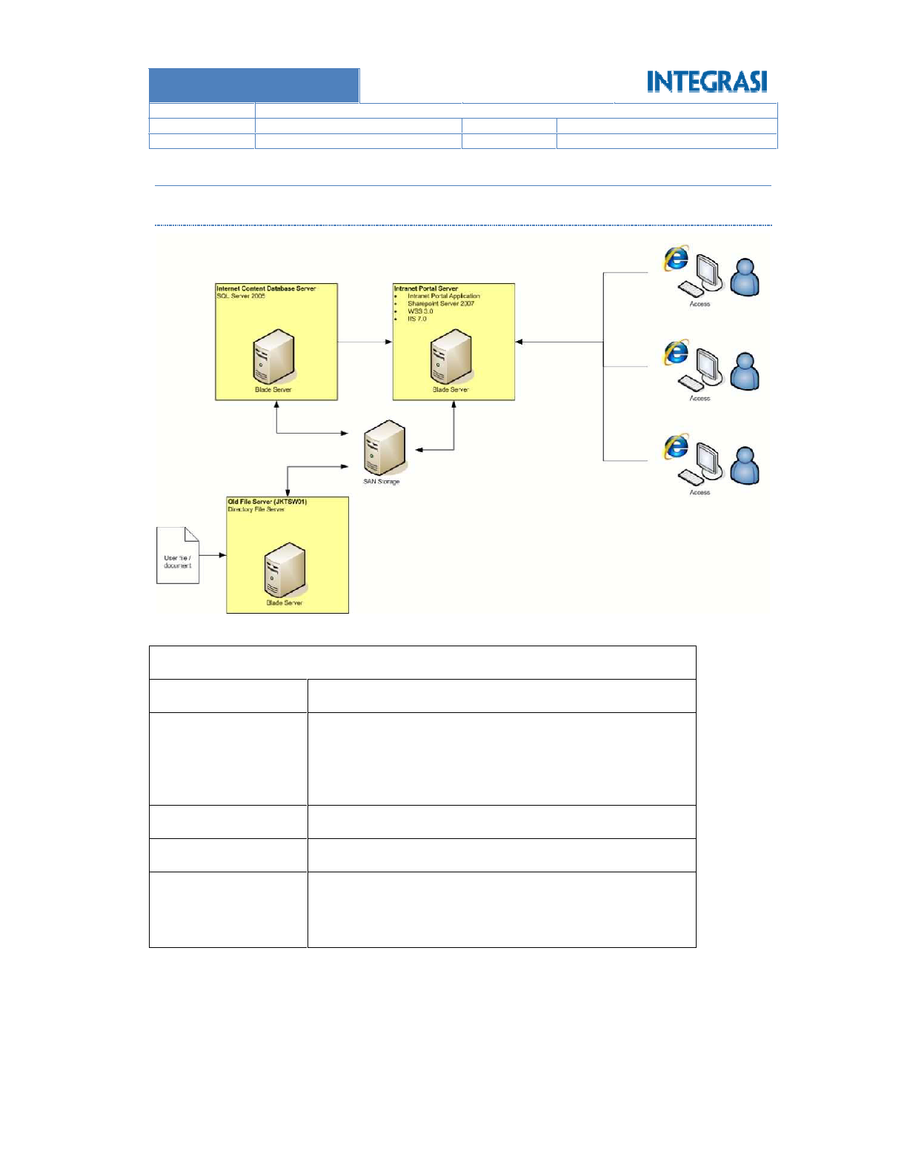

Page **23** of **48**

Sharepoint 2007

 Windows Server 2003 R2 Enterprise Edition with SP2 32bit for

 Windows Server 2008 R2 64 bit (x64)

2x1000 MBps

8GB Redundant Memory / RAID RAM

Operating System

NIC

Memory

FSB Memory 16GB – 32 bit for sharepoint 2007

 4x2400 Intel Xeon E7340 Quad Core 8M Cache 1066 MHz

FSB Memory 16GB 64bit for Sharepoint 2010.

 4x2400 Intel Xeon E7340 Quad Core 8M Cache 1066 MHz

IBM Blade server

Processor

MODEL

**Intranet Database Content Server**

Specification of server and SAN that should be use as follows:

5.3.2.1 Hardware Architecture Diagram

System Architecture Diagram

5.3.2

REVISION 1: FINAL RELEASE

1.0

STATUS

VERSION

CONFIDENTIAL

ARISTEJO

INTRANET PORTAL PROJECT

CLASSIFICATION

AUTHOR

TITLE

**INDONESIA**

**GROUP AJINOMOTO**

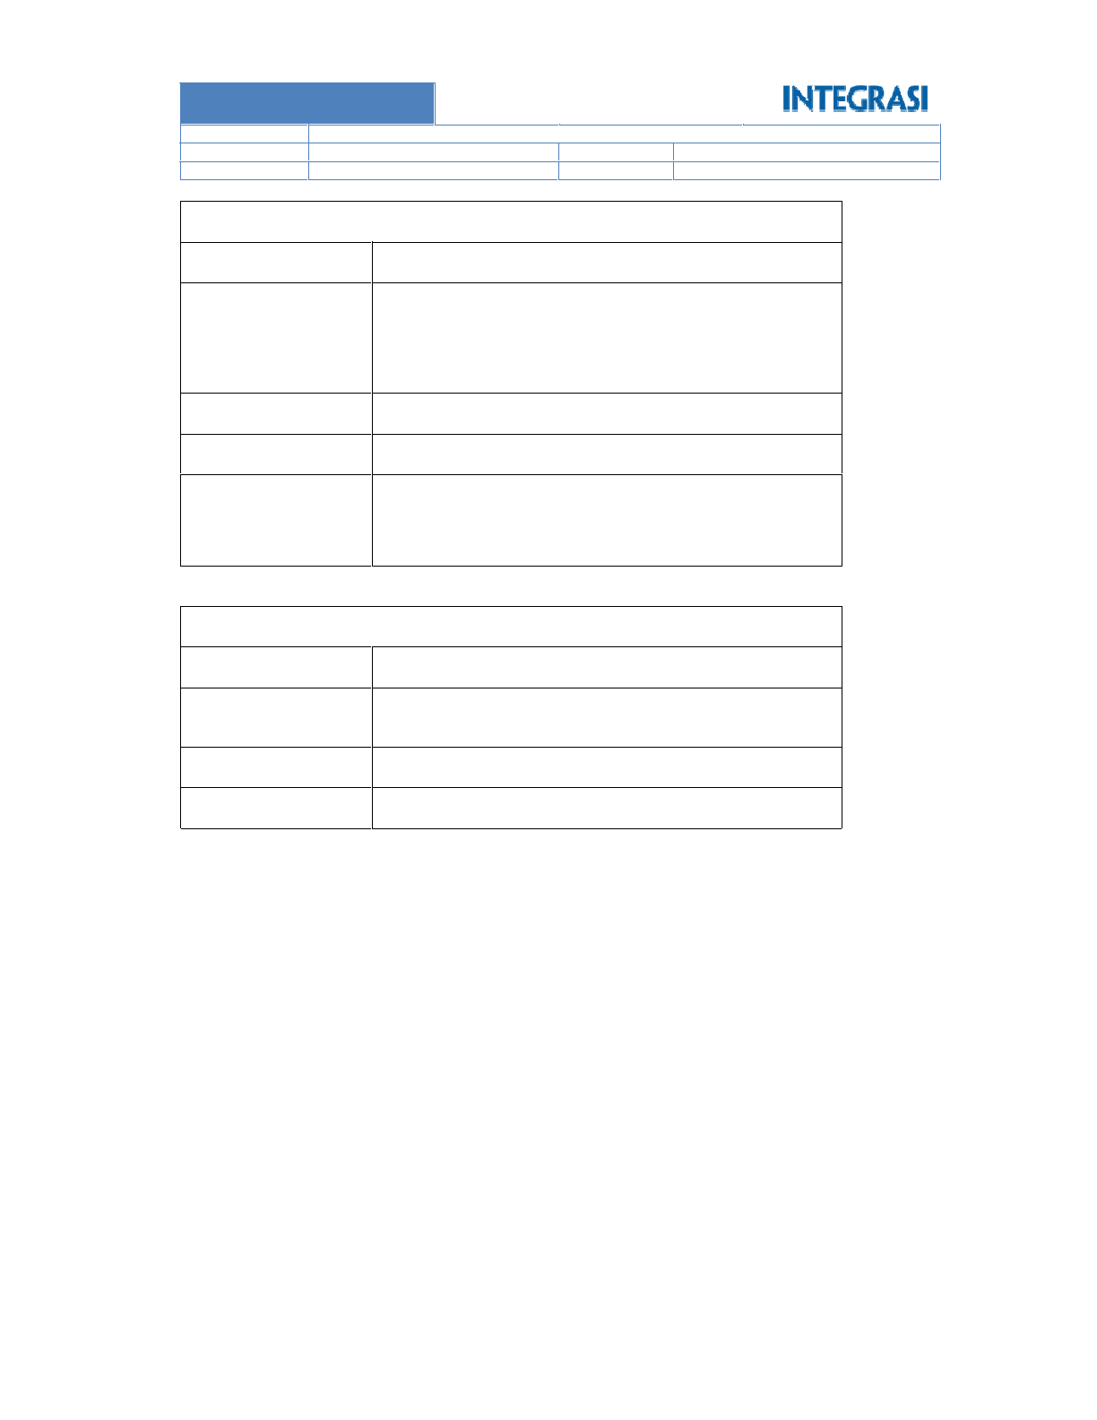

Page **24** of **48**

Network Adapter

Memory

Fiber channel

4GB Redundant Memory / RAID RAM

Memory 16GB, HDD 6x146x15k SAS, RAID 1+0

4x2400 Intel Xeon E7340 Quad Core 8M Cache 1066 MHz FSB

Dell Equal Logic (16 Disk Slot)

Processor

MODEL

**SAN Storage**

Sharepoint 2007

 Windows Server 2003 R2 Enterprise Edition with SP2 32bit for

 Windows Server 2008 R2 64 bit (x64)

2x1000 MBps

8GB Redundant Memory / RAID RAM

Operating System

NIC

Memory

FSB Memory 16GB – 32 bit for sharepoint 2007

 4x2400 Intel Xeon E7340 Quad Core 8M Cache 1066 MHz

FSB Memory 16GB 64bit for Sharepoint 2010.

 4x2400 Intel Xeon E7340 Quad Core 8M Cache 1066 MHz

IBM Blade server

Processor

MODEL

**Intranet Portal Server**

REVISION 1: FINAL RELEASE

1.0

STATUS

VERSION

CONFIDENTIAL

ARISTEJO

INTRANET PORTAL PROJECT

CLASSIFICATION

AUTHOR

TITLE

**INDONESIA**

**GROUP AJINOMOTO**

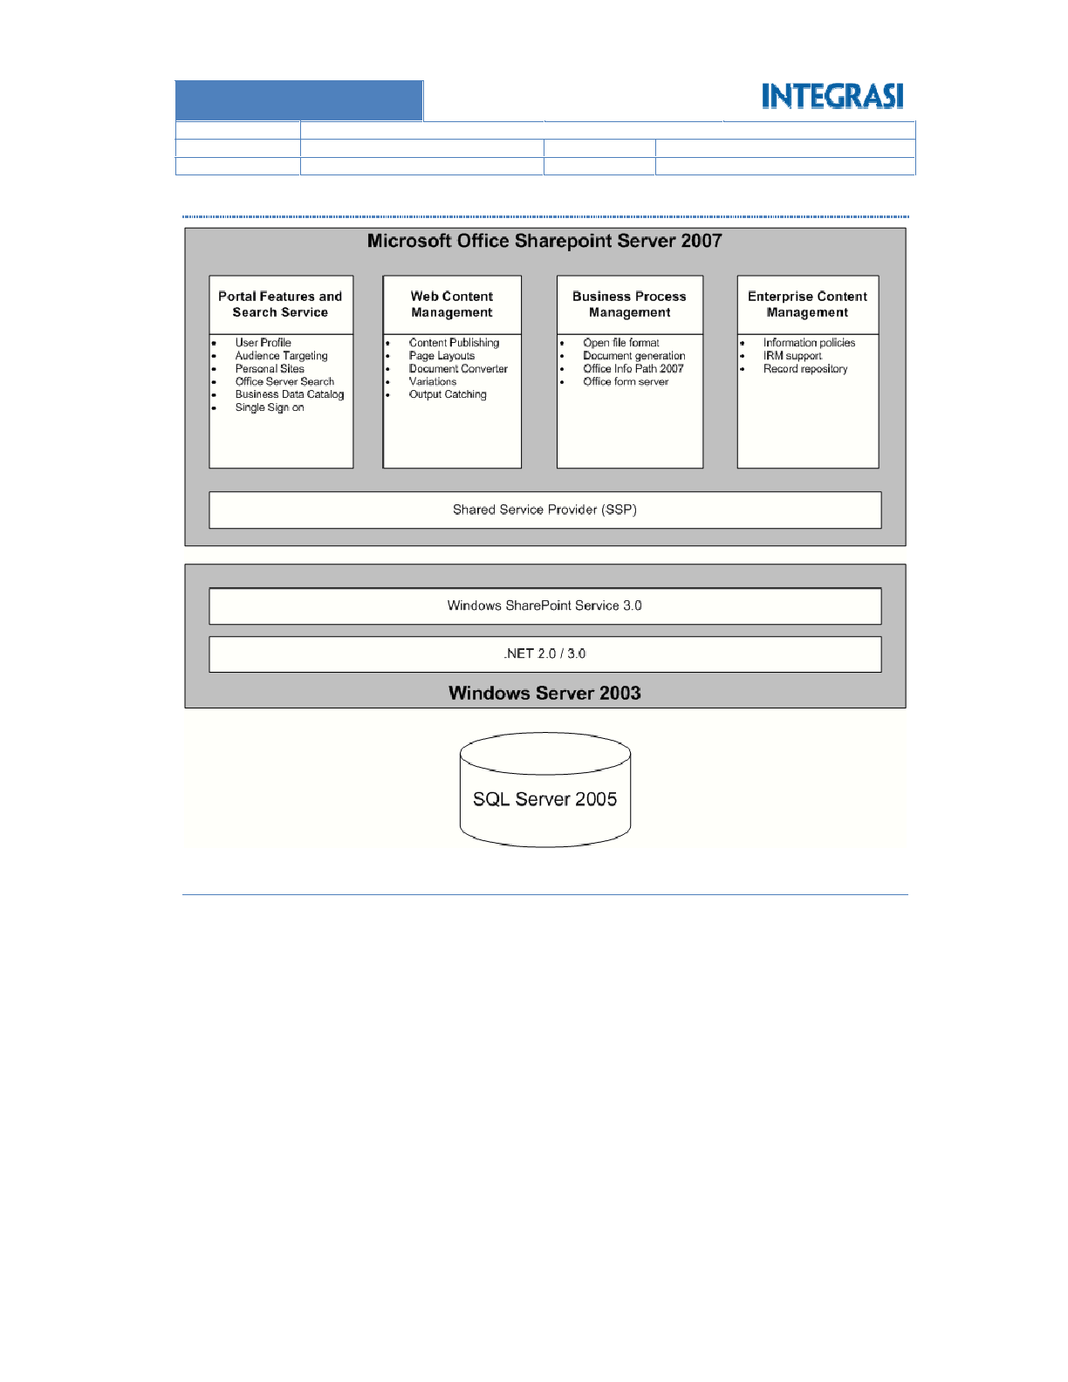

Page **25** of **48**

Visual Studio programming tools but it takes more time and more effort.

accept revise to creator then any reject must be void. For solution we can develop workflow using

Workflow will use basic sharepoint workflow which it use waterfall method. This method can not

We will use basic sharepoint framework, features, and functions in producing intranet portal.

Applications must be running in Microsoft Environment.

System Constrain







5.3.3

5.3.2.2 Software Architecture Diagram

REVISION 1: FINAL RELEASE

1.0

STATUS

VERSION

CONFIDENTIAL

ARISTEJO

INTRANET PORTAL PROJECT

CLASSIFICATION

AUTHOR

TITLE

**INDONESIA**

**GROUP AJINOMOTO**

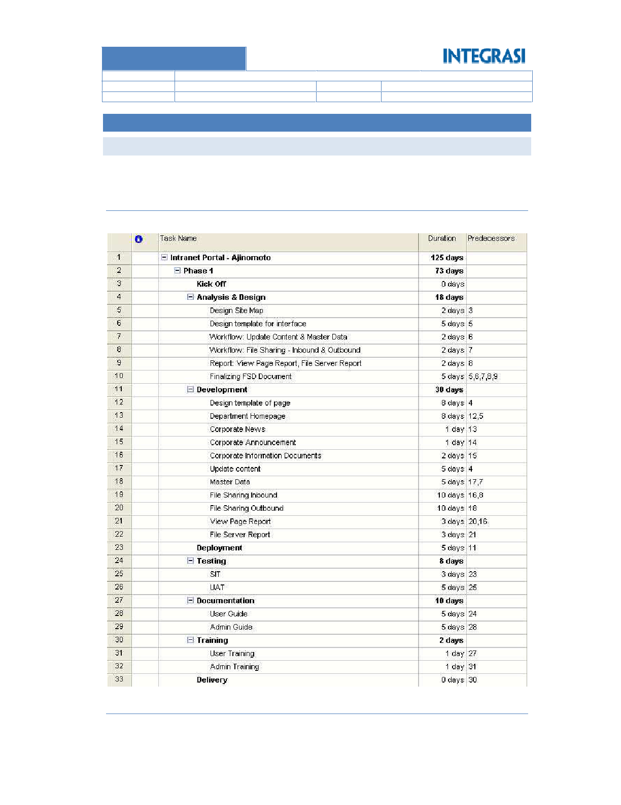

Page **26** of **48**

Duration of Phase 1 Project is **52** working days. The project charter is as follows:

Phase 2

6.1.2

Duration of Phase 1 Project is **73** working days. The project charter is as follows:

Phase 1

6.1.1

each phase is as follows.

Project is devided into 2 phases. Total duration for phase 1 and phase 2 is **125 working days**. Breakdown of

PROJECT SCHEDULE

**PROJECT MANAGEMENT**

6.1

**6**

REVISION 1: FINAL RELEASE

1.0

STATUS

VERSION

CONFIDENTIAL

ARISTEJO

INTRANET PORTAL PROJECT

CLASSIFICATION

AUTHOR

TITLE

**INDONESIA**

**GROUP AJINOMOTO**

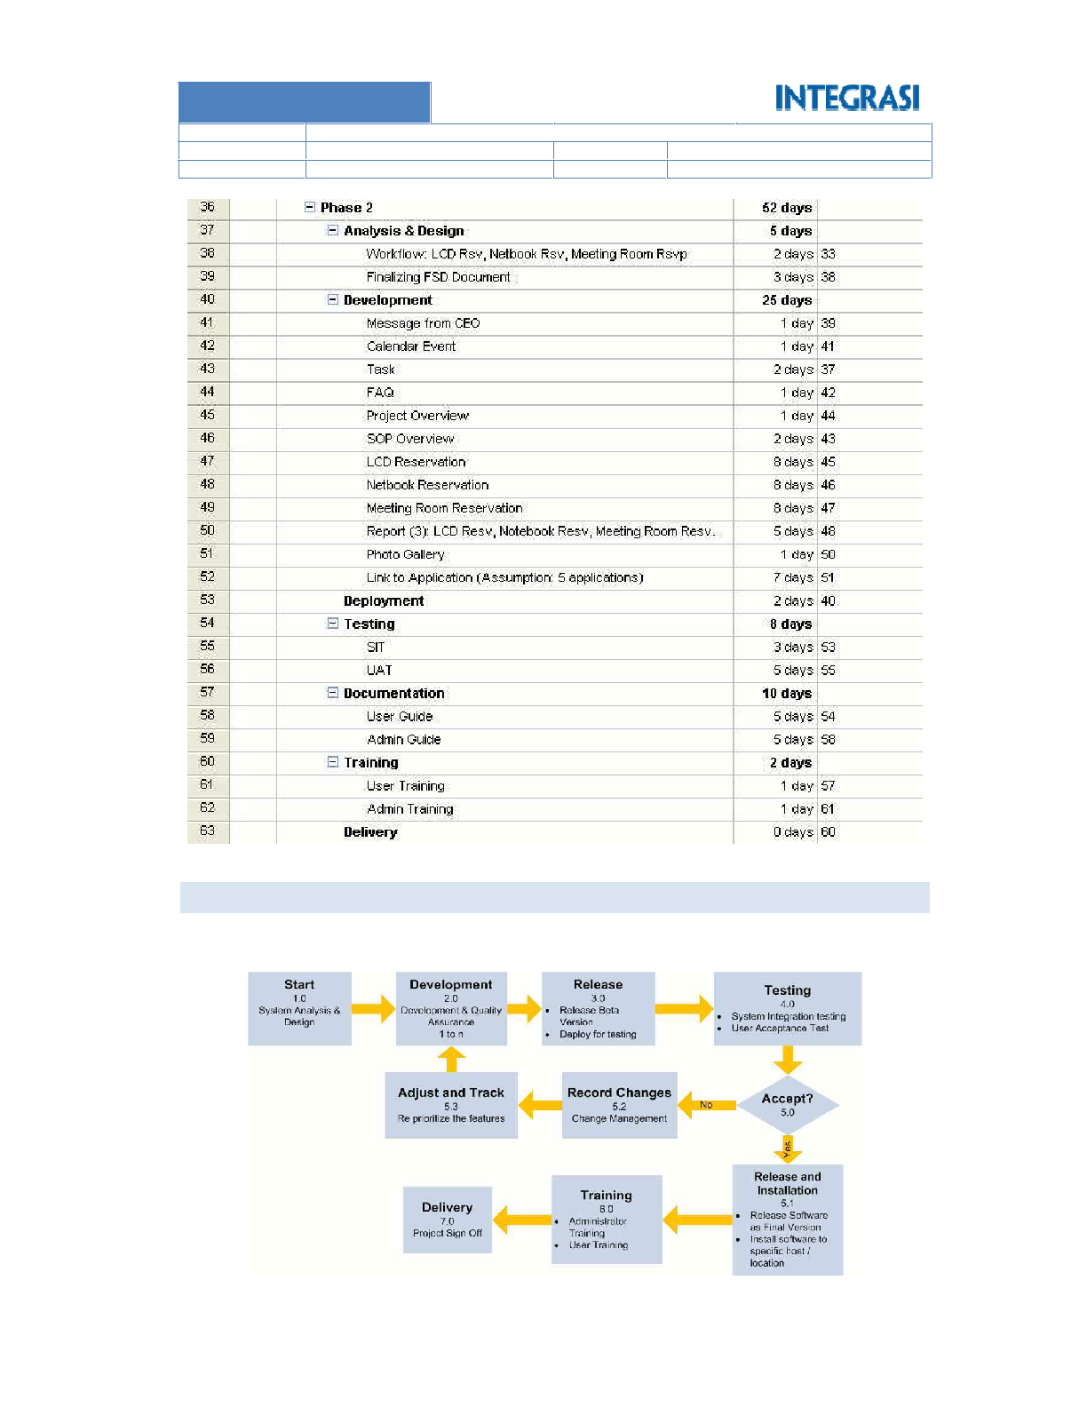

Page **27** of **48**

the figure below:

This project will use the agile programming methodology. The scheme of Agile Programming is describe in

METHODOLOGY

6.2

REVISION 1: FINAL RELEASE

1.0

STATUS

VERSION

CONFIDENTIAL

ARISTEJO

INTRANET PORTAL PROJECT

CLASSIFICATION

AUTHOR

TITLE

**INDONESIA**

**GROUP AJINOMOTO**



Page **28** of **48**

Formal testing result document

background.

technical

from

mostly

technical aspect. The team

This testing is performing in

Testing

Integration

System

**Testing**

Testing schedule

Testing scheme

be tested

Beta Version ready to







project owner team.

and how the involvement of

sounding the testing schedule

application meanwhile PM will

the

test

to

documents

produce the testing scheme

The developer team will

tested by project owner.

installed on testing server to be

The beta version application is

Deployment

**Release**

Beta Version Software

soon.

pass QA and it will be release

as Beta Version whenever has

Application will be identified

complete application.

it assembles into a module or a

result package by package until

assurance (QA) is checking the

was in progress, the quality

Meanwhile the development

parties.

already sign off by both

base on design document that

Development of applications

Development

Software

**Development**





be sign off by both party.

All final design document must

analysis sector.

responsible to business

of project owner that

SA will collaborate with team

technical design.

analyst the requirement into

System analysts (SA) will

&

Design

Analysis



Design Document

Document

Specification

Functional

agreement

communication model

rules, and

Schedule, project

people in charge

structure with the

Project organization



**Deliverables**

management will do.

about how the project

are creating an agreement

It is PM meeting. Both parties

**Description**

Kick Off

**Action**

**Starting**

**Phase**

The entity description is listed in the table below:

REVISION 1: FINAL RELEASE

1.0

STATUS

VERSION

CONFIDENTIAL

ARISTEJO

INTRANET PORTAL PROJECT

CLASSIFICATION

AUTHOR

TITLE

**INDONESIA**

**GROUP AJINOMOTO**







Page **29** of **48**

related to project

Other document

Document

Troubleshooting

Administrator

for User and

Guidance Document

signed off

document must be

owner. Delivery

result to project

accomplished. Deliver

Project is



Project Sign Off

**Delivery**

software

Users are ready to operate

User Training

Formal testing result document

Version Software

Installation final

Final version Software





operate software

Administrator is ready to



phase will deliver as well.

All related document in this

delivery.

the document of project

project. Both PM will sign off

This is the final phase of the

use the system.

to system users about how to

Integrasi will conduct training

administrator.

as

system

the

use

to administrator about how to

Integrasi will conduct training

Training

Administrator

**Training**

be installed on the real server.

This final version software will

software.

release the final version

refinement, Integrasi shall

the

completing

After

Install Software

**Installation**

**Release &**

project owner accept the result.

development phase again until

activities will iterate from

Mostly from this phase, all

before.

testing scenario that built

The testing must follow the

signed off by both party.

result will be documented and

All error and unrespectable

business process background.

team mostly from user and

user and process aspect. The

This testing is performing in

Test

User Acceptance

before.

testing scenario that built

The testing must follow the

signed off by both party.

result will be documented and

All error and unrespectable

REVISION 1: FINAL RELEASE

1.0

STATUS

VERSION

CONFIDENTIAL

ARISTEJO

INTRANET PORTAL PROJECT

CLASSIFICATION

AUTHOR

TITLE

**INDONESIA**

**GROUP AJINOMOTO**

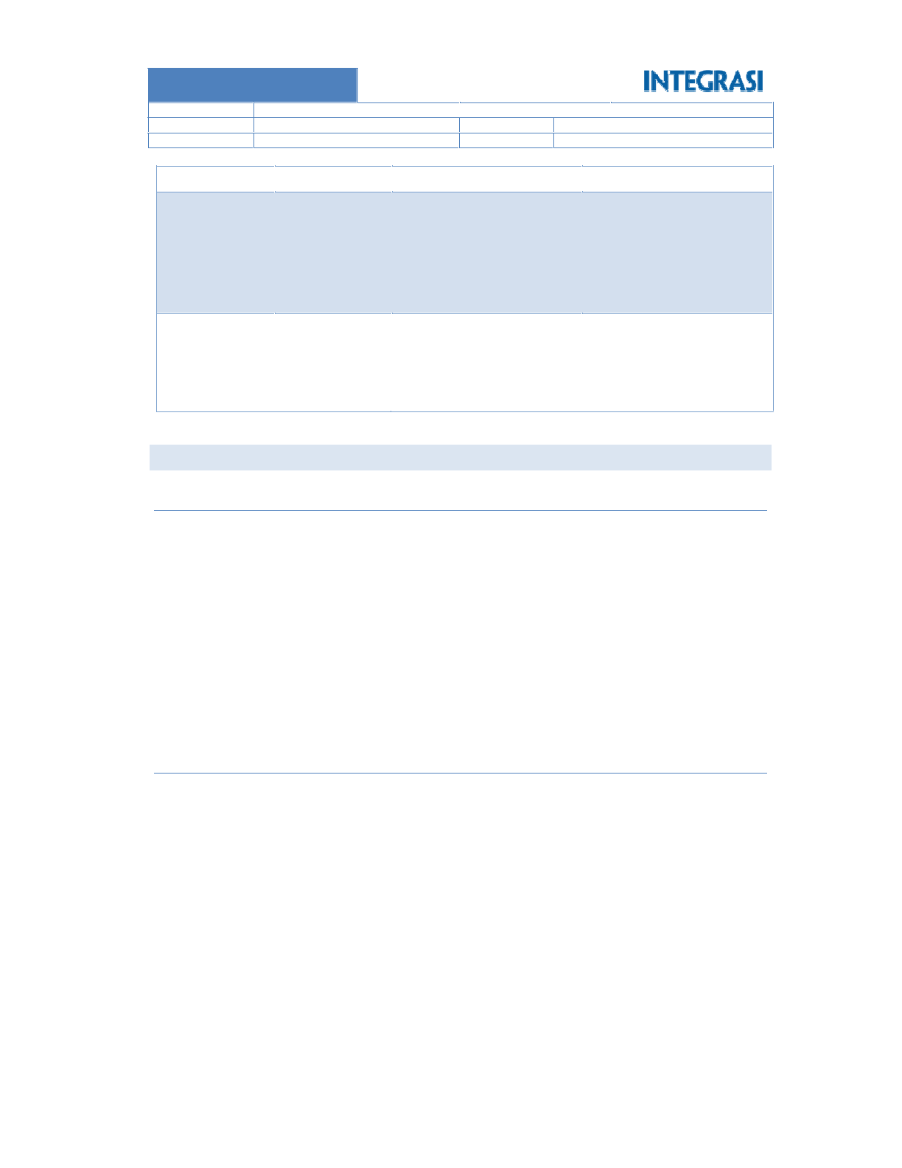

Page **30** of **48**

Set of PC. Provided by Ajinomoto

Access to intranet portal

o

o

Tools needed:

Model: Worksop





Minor Troubleshooting

Guideline to manage data from external source

Guideline to manage content

Guidelines to manage access

Introducing new intranet portal

o

o

o

o

o

Sylabus:

Duration: 1 day

Administrator Training





6.3.2

Set of PC. Provided by Ajinomoto

Access to intranet portal

o

o

Tools needed:

Model: Worksop

Guideline to use modules inside (reservation)

Guideline to manage content (news, announcement, calendar event, etc.)

Introducing new intranet portal





o

o

o

Sylabus:



Duration: 1 day

User Training

USER TRAINING

6.3.1

6.3

Changing and adjustment map

result

Changes list

list

Unacceptable





expectations.

fulfill

to

solutions

select the changes and decide

then Developer team will

After all changes has recorded,

condition

result to existing

Mapping testing

**Adjust & Track**

what action should be taken.

adjust then PM will decide

adjust. If the changes cannot be

Select the changes that can be

must be record in a log.

All changes an unexpectations

Management

Change

**Record Changes**

delivery.

REVISION 1: FINAL RELEASE

1.0

STATUS

VERSION

CONFIDENTIAL

ARISTEJO

INTRANET PORTAL PROJECT

CLASSIFICATION

AUTHOR

TITLE

**INDONESIA**

**GROUP AJINOMOTO**

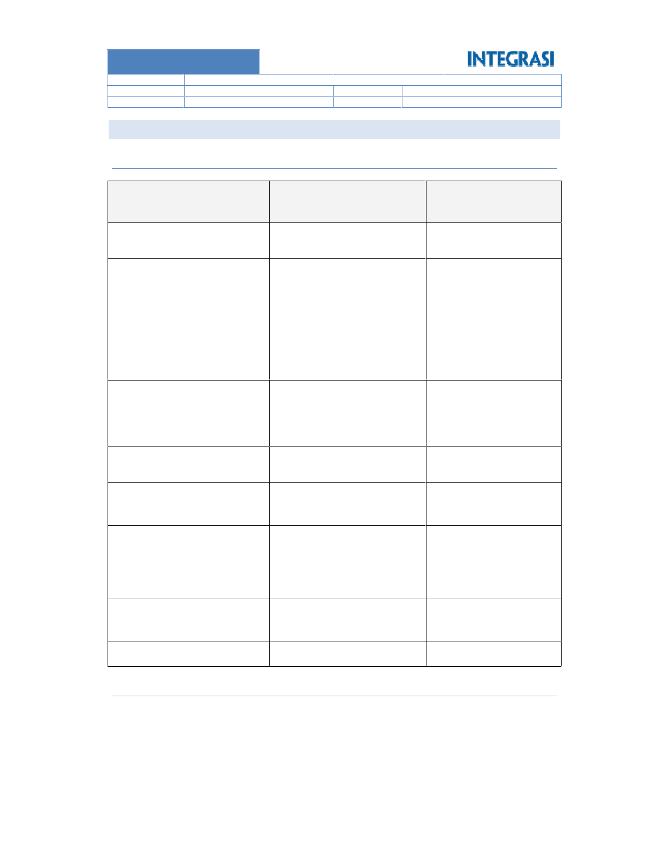

Page **31** of **48**

Progress Report

Project Documentation: Minutes of meeting, etc.

Deliverables By SDLC





6.4.2

Sign off documents

Application fully operated by client

Delivery

Training event document

 Training for administrator

 Training for user or trainer

Training

administrator.

Guidance book for user and

print out as well.

 Could be in soft copy (CD) or

 Administrator Guide Document

 User Guide Document

Documentation

Testing document.

Testing

Deployment document

 User acceptance test (UAT)

 System integration test (SIT)

production server

Application / modules installed on

Deployment

Roll out documents

one big piece application as well

 Could be delivered in modular or

to be tested

 Modules / application that ready

Development

Document (TSD)

 Technical Specification

Document (FSD)

 Functional Specification

System Analysis and Design

MoM Kick Off.

 Technical design.

 Interface design.

Off Documents.

relate to proposal and MoM Kick

 Other user requirements that

 Functional requirements.

 Business requirements.

between client and Integrasi.

Project management Agreement

Kick Off Meeting

**to be Signed Off**

**Documents**

**Deliverables**

**Project Step**

Deliverables By Phase

PROJECT DELIVERABLES

6.4.1

6.4

REVISION 1: FINAL RELEASE

1.0

STATUS

VERSION

CONFIDENTIAL

ARISTEJO

INTRANET PORTAL PROJECT

CLASSIFICATION

AUTHOR

TITLE

**INDONESIA**

**GROUP AJINOMOTO**

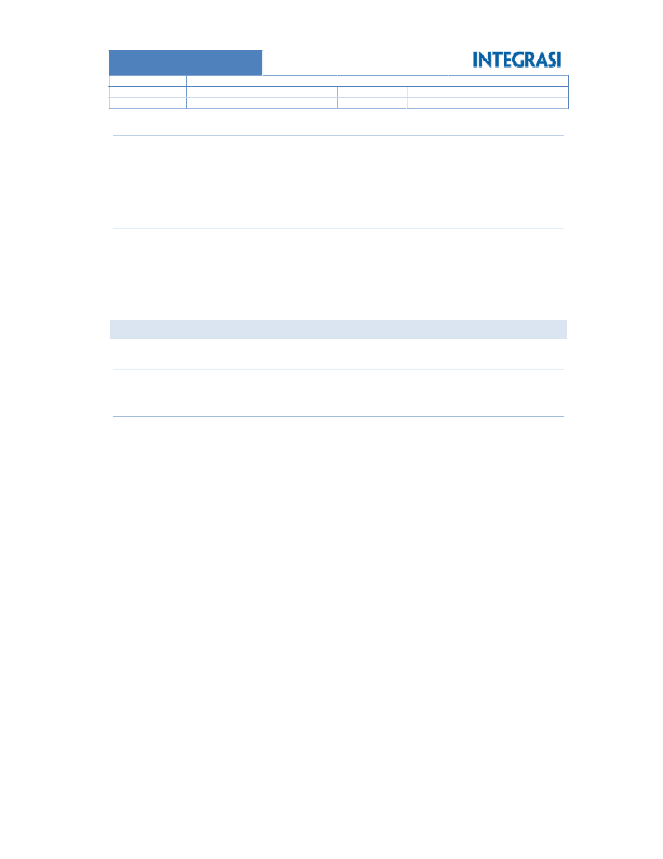

Page **32** of **48**

Unlimited telephone and email support

Office hour Monday thru Friday : 08:00 AM – 17:00 PM

o

o

Support Coverage:

All support will be done on working days and working hours in Jakarta.

Integrasi can change the team member and change them with another person.

Maintenance will not upgrade the application. Its focus on error and malfunction only.

Maintenance scope is error refinement only.

Maintenance is valid for 3 months starting from end of delivery phase.













Term of Maintenance:

Maintenance Cost

6.5.2

Implementation Cost

QUOTATION

6.5.1

6.5

working hour will be responded on next business day.

All support will be performing on working days and working hours in Jakarta. Request at non

Maintenance will not upgrade the application. It focuses on error and malfunction only.

Maintenance scope is error refinement only.

Maintenance period is 1 year after Sign off Phase.

Maintenance Scheme









6.4.4

Traning for user and admin

User Guide and Admin Guide

Intranet Portal

Deliverables By Project







6.4.3

REVISION 1: FINAL RELEASE

1.0

STATUS

VERSION

CONFIDENTIAL

ARISTEJO

INTRANET PORTAL PROJECT

CLASSIFICATION

AUTHOR

TITLE

**INDONESIA**

**GROUP AJINOMOTO**



Page **33** of **48**

and remote areas all over Indonesia in 51 days.

We distributed, installed, and supported 8,000 personal computers to around 5,000 locations in cities, rural

country.

We built data center and disaster recovery center that connect to all the 8000 personal computers all over the

Pemilihan Umum (KPU) or The National Elections Commission.

We successfully developed, deployed and supported Information Technology infrastructure for Komisi

2004 in Indonesia.

INTEGRASI won the Election 2004 project. It was the single largest and the most complex IT project in

**NATIONAL ELECTION**

Special Achievement

7.1.3

To help generate opportunities for growth.

To increase employee productivity and

To support goals of cost reduction,

To facilitate business,









INTEGRASI believe every organization are looking for systems and solutions to deliver on essential goals:

Our total solution has been a unique competitive advantage of our company.

Since the start-up in 1989, INTEGRASI focuses on finding the most cost effective and innovative solutions.

**Company Background**

To provide an environment as the destination for the best people

To achieve significant and sustainable growth

To be a trusted business partner for our customers and business alliances

To be the leading and innovative IT service company in Indonesia









**Mission:**

To understand client’s needs and provide outstanding Infrastructure and Business solutions.

Company profile



**Vision**

7.1.2

: 021-5711002

: 021-5711400

Fax

Phone

Company Name : PT INTEGRASI SOLUTION

Address

7.1.1

Jl. Jend. Sudirman Kav. 22 – 23

: Barclay’s House I 9th Fl

Company Address

COMPANY OVERVIEW

**APPENDIX**

7.1

**7**

REVISION 1: FINAL RELEASE

1.0

STATUS

VERSION

CONFIDENTIAL

ARISTEJO

INTRANET PORTAL PROJECT

CLASSIFICATION

AUTHOR

TITLE

**INDONESIA**

**GROUP AJINOMOTO**

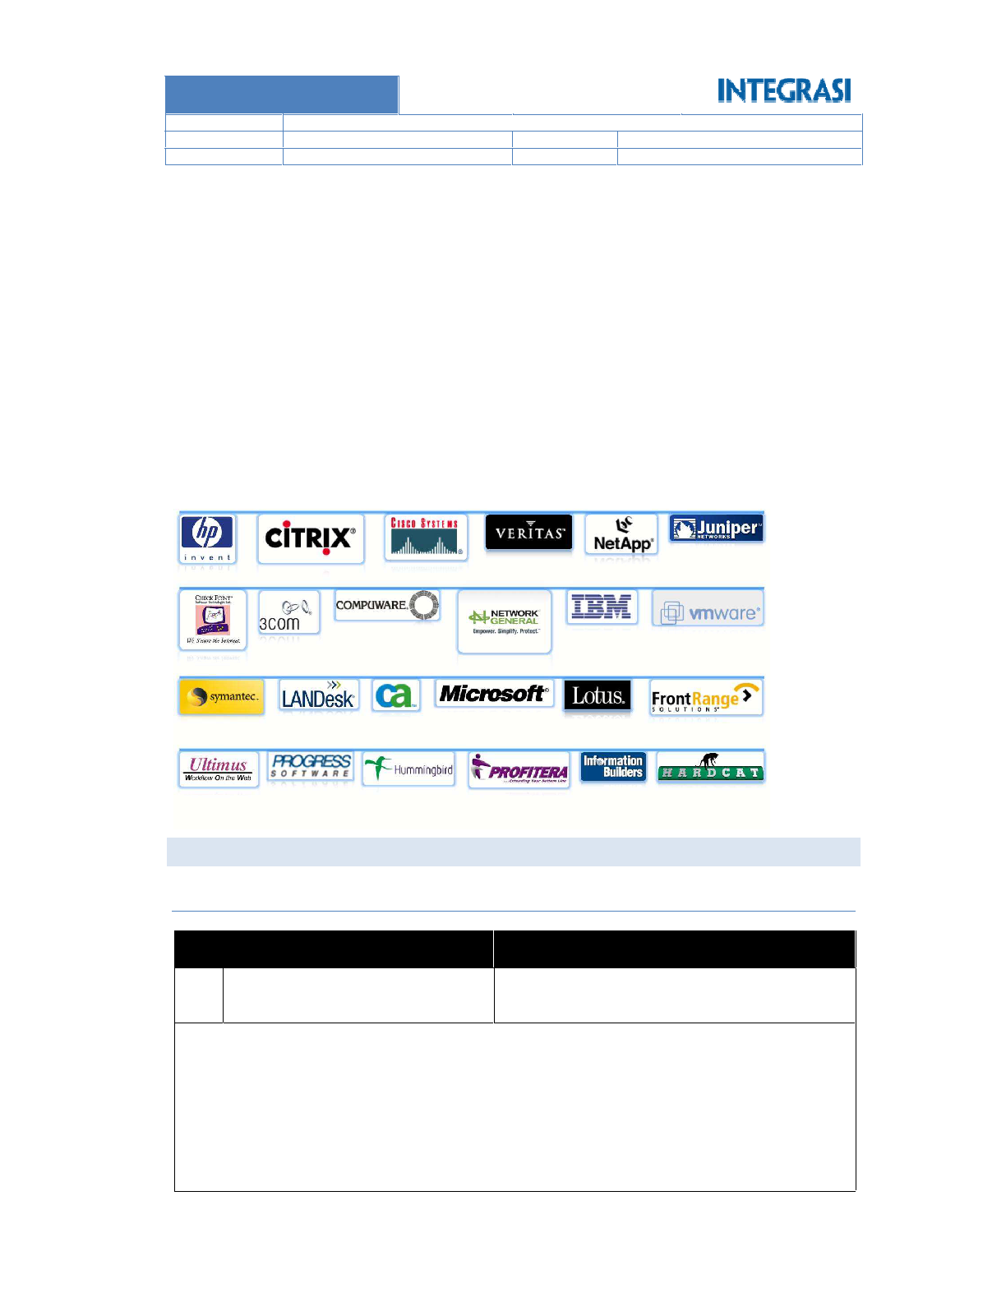

Page **34** of **48**

o Annual Leave Application

Additional applications:

Image Gallery

Document Management

Discussion

Corporate Events

Corporate News













Installation and Implementationof corporate portal using Share Point Portal with features:

Tanjung Barat

Gedung Aneka Tambang, Jl. TB Simatupang No 1

**Location**

Aneka Tambang, Tbk

**Company Name**

Aneka Tambang

PROJECT EXPERIENCE

1

No

7.2.1

7.2

**Strategic Business Par**t**ner**

Total man days we provide to LG CNS are 18.000,- man days.

Oracle DBA, System Analyst, Developer, Quality Assurance and Technical Writer

We provide outsourcing professional services with total resources: 70 resources consist of Project Manager,

Integrasi was selected to become LG CNS Partner.

LG CNS wins the tender for “Indonesian National Crime Information System”

**OUTSOURCING FOR LG CNS**

The project completed successfully.

We provided help desk support to all technical issue 7x24 for one year.

These infrastructures supported three elections: DPR, first and second Presidential Election.

(Legislative I, Legislative II, and Presidential Election).

We distributed, deployed and reinstalled the application to all personal computers for three elections

REVISION 1: FINAL RELEASE

1.0

STATUS

VERSION

CONFIDENTIAL

ARISTEJO

INTRANET PORTAL PROJECT

CLASSIFICATION

AUTHOR

TITLE

**INDONESIA**

**GROUP AJINOMOTO**

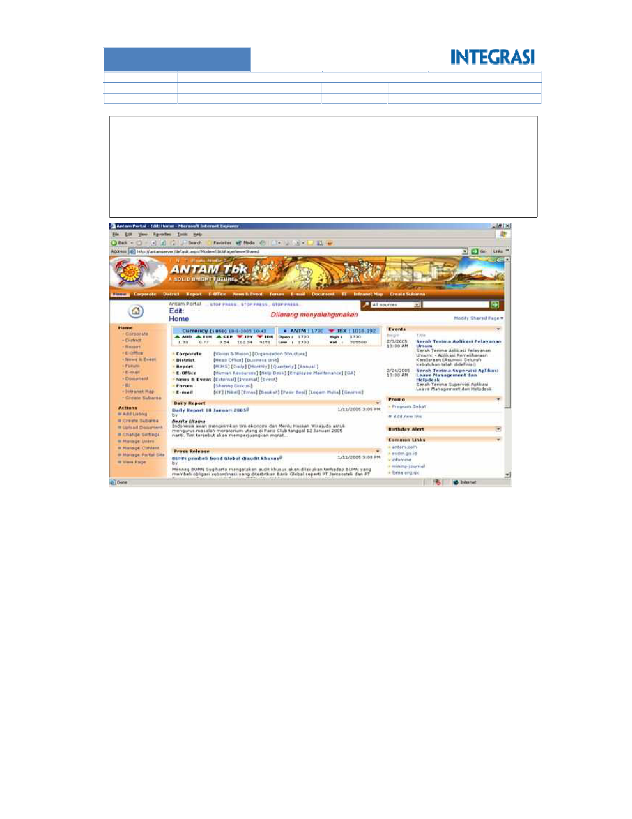

Page **35** of **48**

Help Desk Application

Employee Self Service Application integrate dengan ERP (MIMS)

ATK Application

Vehicle Reservation Application

Vehicle Maintenance Application

eProcurement Application

Meeting Room Reservation Application

SPJ Application

o

o

o

o

o

o

o

o

REVISION 1: FINAL RELEASE

1.0

STATUS

VERSION

CONFIDENTIAL

ARISTEJO

INTRANET PORTAL PROJECT

CLASSIFICATION

AUTHOR

TITLE

**INDONESIA**

**GROUP AJINOMOTO**

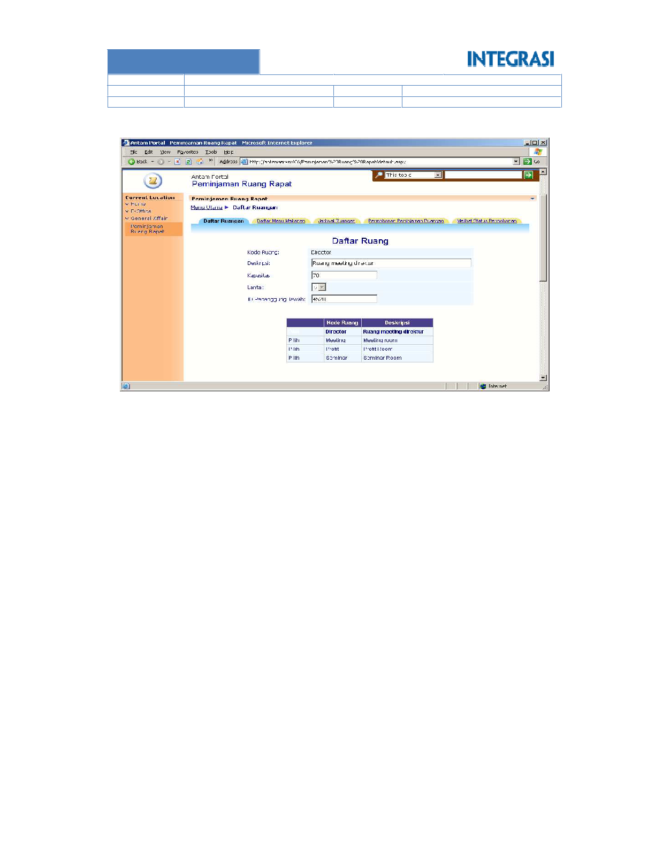

Page **36** of **48**

**Meeting Room Reservation Application**

REVISION 1: FINAL RELEASE

1.0

STATUS

VERSION

CONFIDENTIAL

ARISTEJO

INTRANET PORTAL PROJECT

CLASSIFICATION

AUTHOR

TITLE

**INDONESIA**

**GROUP AJINOMOTO**

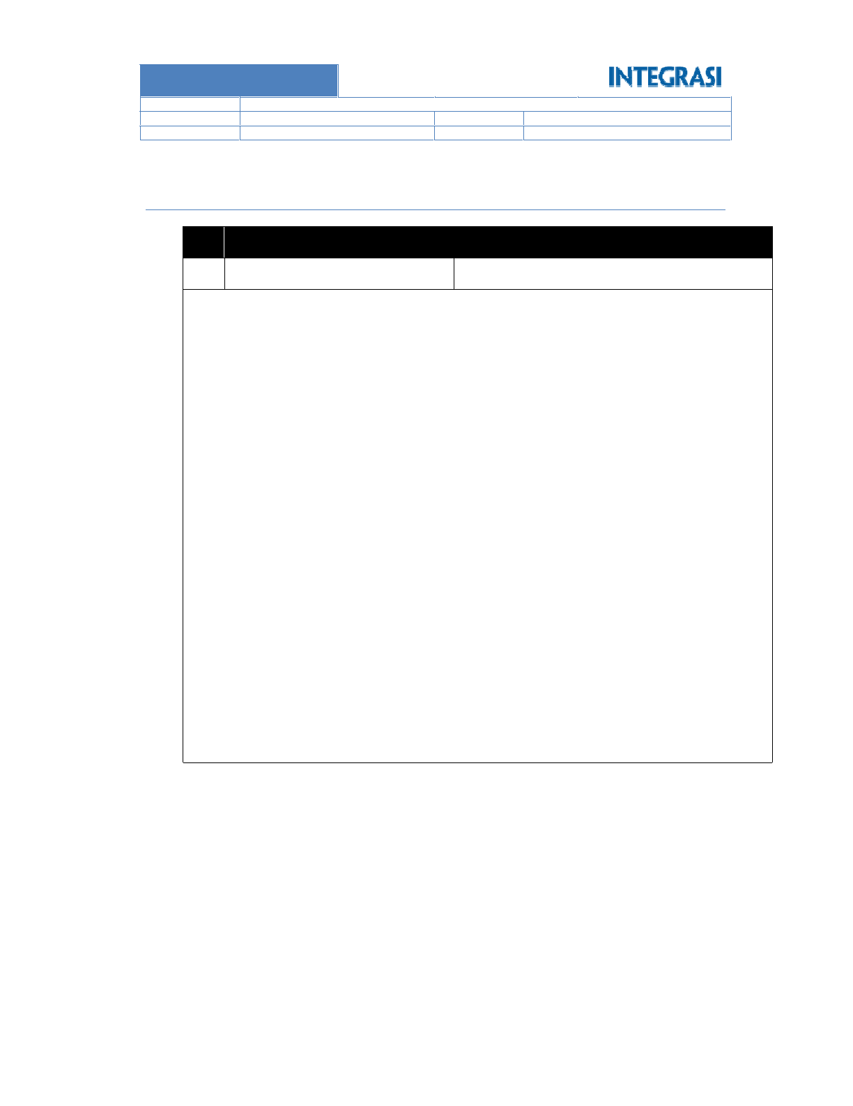

Page **37** of **48**







o Meeting room reservation

Additional application

o Mills

o Human Resource

o Marketing

o Finance

o Operation

o IT Services

o Legal

Knowledge Management

o Image Gallery

o Birthday Alert

o Memo

o Room Reservation Application

o Polling

o Event

o News

o Personal Site (My Site)

o Team Site Region

Intranet Portal

o Sitemap

o Image Gallery

o Feedback

o Careers

o Corporate Event

o Corporate Announcement

o SpotLight

o Corporate News

Internet Portal



Installation and Implementationof corporate portal using Share Point Portal with features:

Plaza Central Lt 5. Jl. Sudirman Kav 47 Jakarta 12930

**Location**

Minamas Plantation, Tbk

**Company Name**

2

No

Minamas Plantation

7.2.2

REVISION 1: FINAL RELEASE

1.0

STATUS

VERSION

CONFIDENTIAL

ARISTEJO

INTRANET PORTAL PROJECT

CLASSIFICATION

AUTHOR

TITLE

**INDONESIA**

**GROUP AJINOMOTO**

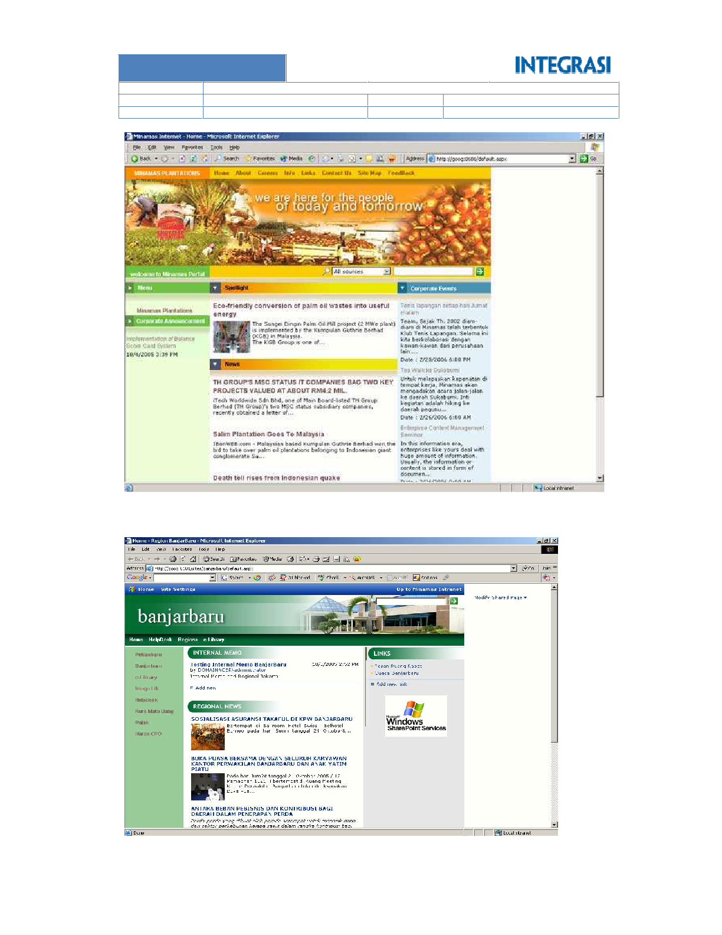

Page **38** of **48**

**Minamas Team Site**

REVISION 1: FINAL RELEASE

1.0

STATUS

VERSION

CONFIDENTIAL

ARISTEJO

INTRANET PORTAL PROJECT

CLASSIFICATION

AUTHOR

TITLE

**INDONESIA**

**GROUP AJINOMOTO**

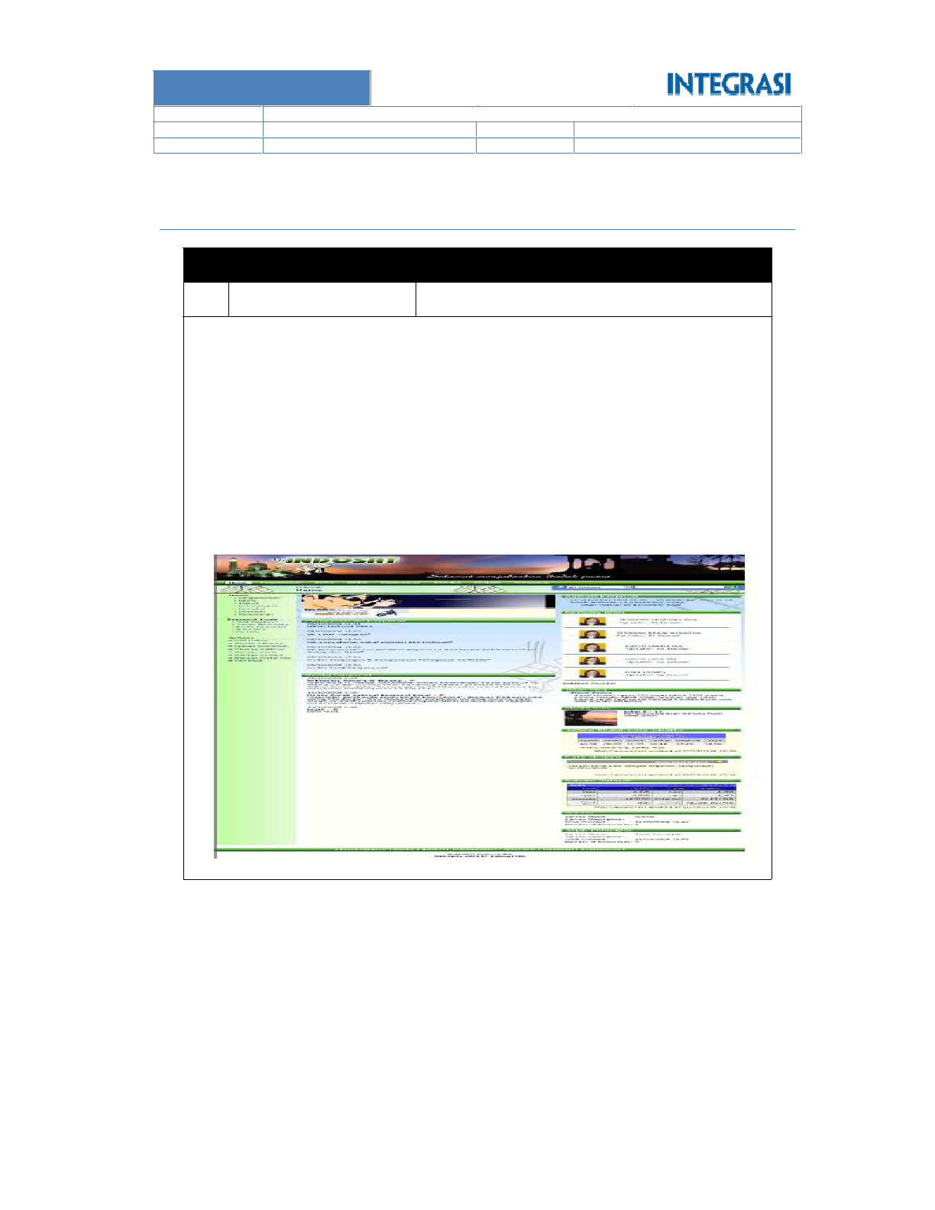

Page **39** of **48**

Help Desk Application

Index Saham application

Shalat Time application

Integrate with existing HR Application (SAP Based)

Iklan Baris

Image Gallery

Elearning through Video Streaming

Document Management

Discussion

Corporate Events

Corporate News























Installation and Implementation of corporate portal using Share Point Portal with features:

3

No

Jalan Medan Merdeka Barat 21, Jakarta Pusat

Location

INDOSAT, Tbk

Company Name

Indosat

7.2.3

REVISION 1: FINAL RELEASE

1.0

STATUS

VERSION

CONFIDENTIAL

ARISTEJO

INTRANET PORTAL PROJECT

CLASSIFICATION

AUTHOR

TITLE

**INDONESIA**

**GROUP AJINOMOTO**

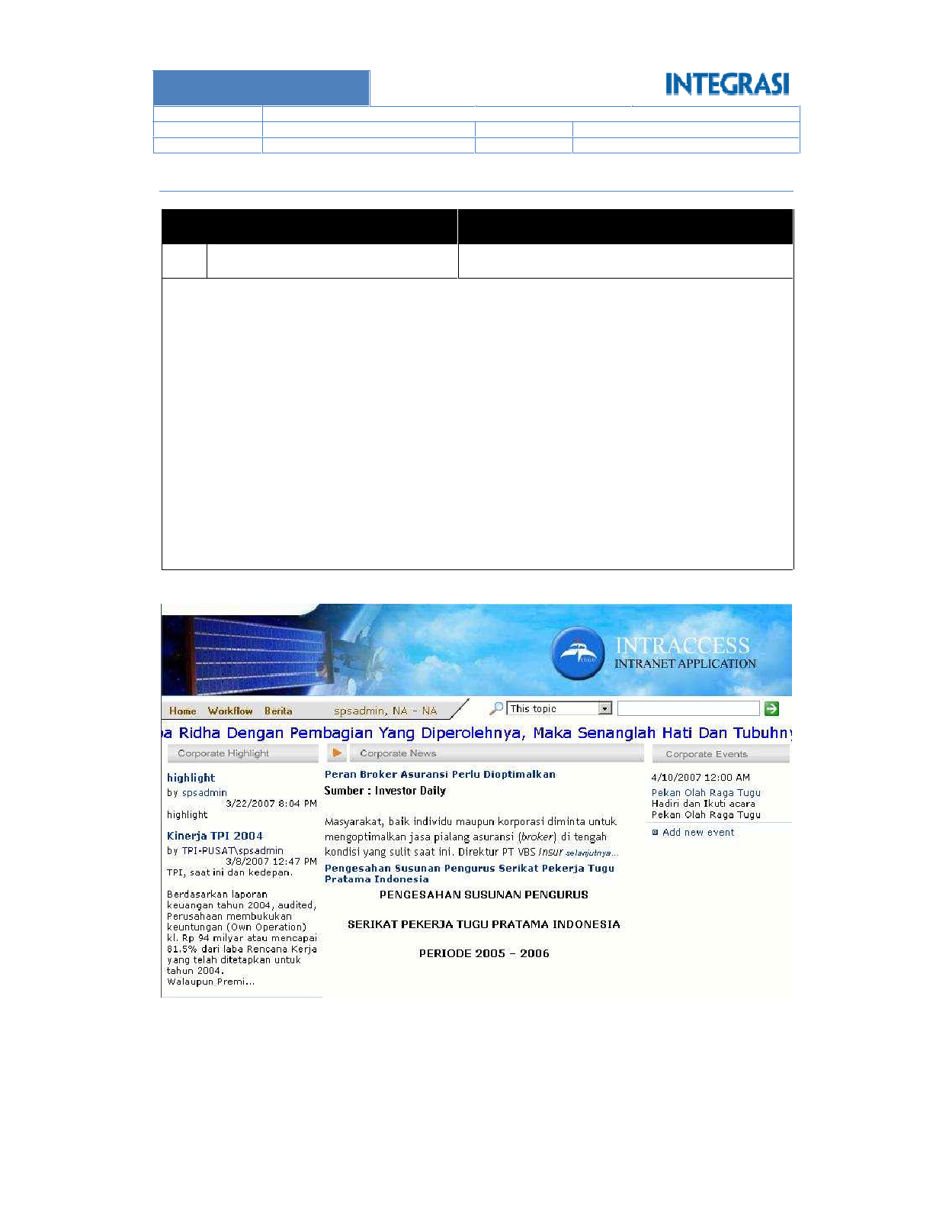

Page **40** of **48**

o Help Desk Application

o Vehicle Reservation Application

o Vehicle Maintenance Application

o Meeting Room Reservation Application

o Annual Leave Application

Applications:

Image Gallery

Pooling / Voting

Discussion

Tips

Antar Anggota

Corporate Highlight

Corporate Events

Corporate News



















Installation and Implementationof corporate portal using Share Point Portal with features:

Wisma Tugu I. Jl HR Rasuna Said - Jakarta

**Location**

Asuransi Tugu Pratama

**Company Name**

Asuransi Tugu

1

No

7.2.4

REVISION 1: FINAL RELEASE

1.0

STATUS

VERSION

CONFIDENTIAL

ARISTEJO

INTRANET PORTAL PROJECT

CLASSIFICATION

AUTHOR

TITLE

**INDONESIA**

**GROUP AJINOMOTO**

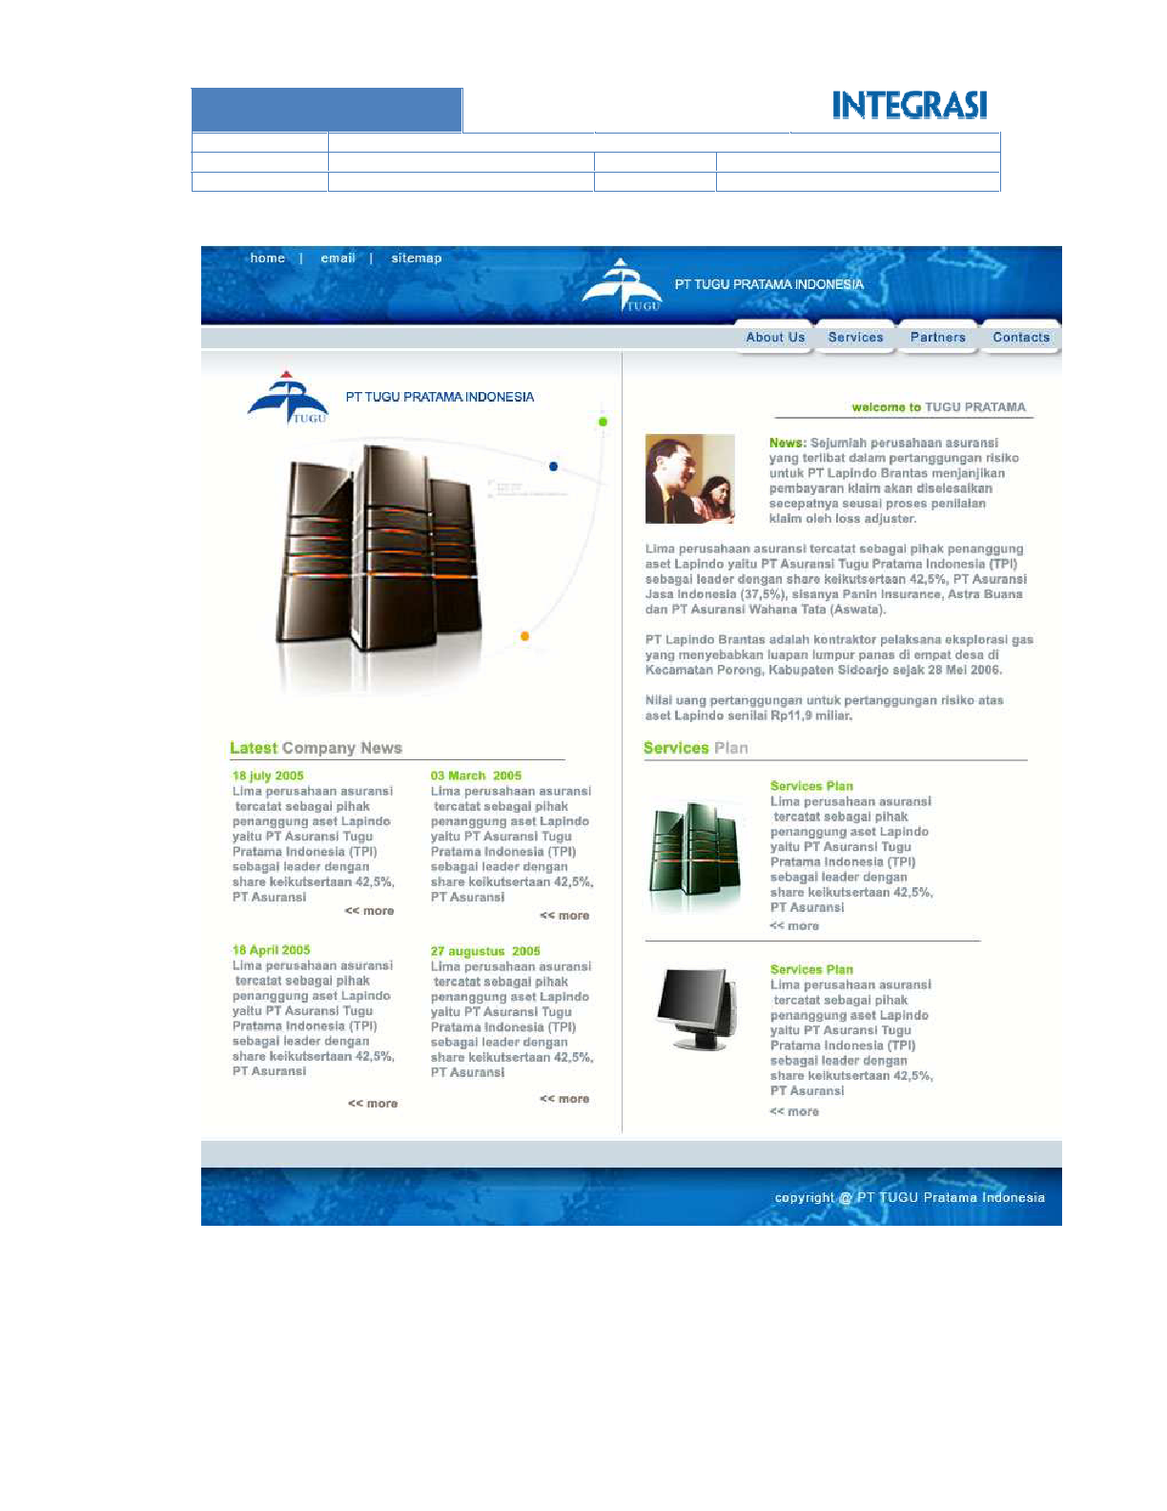

Page **41** of **48**

**IT Dept**

REVISION 1: FINAL RELEASE

1.0

STATUS

VERSION

CONFIDENTIAL

ARISTEJO

INTRANET PORTAL PROJECT

CLASSIFICATION

AUTHOR

TITLE

**INDONESIA**

**GROUP AJINOMOTO**

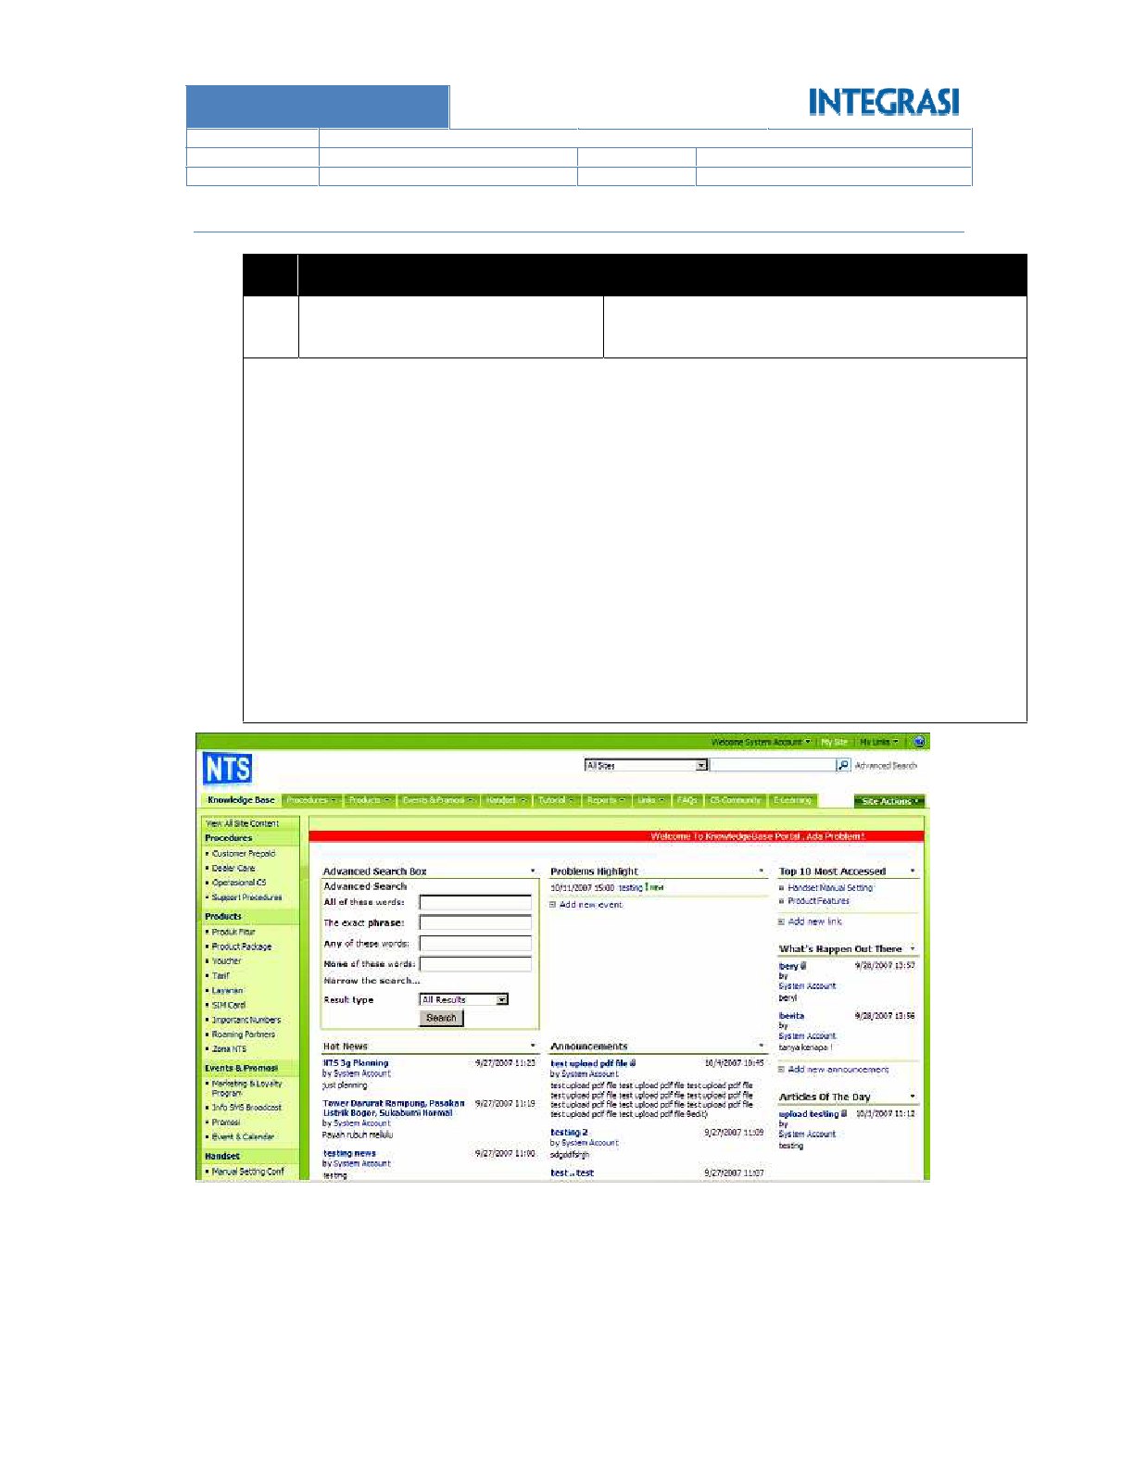

Page **42** of **48**



o Meeting room reservation

Additional application

Human Resource

Marketing

Finance

Operation

IT Services

Legal

o Department:

o Announcement

o Top 10 most access

o Articles of the day

o What’s happened out there

o Problems highlight

o Hot news

Knowledge Management



Installation and Implementationof corporate portal using Share Point Portal with features:

Barat – Jakarta

Manara Axis – DEA Tower Complex. Mega Kuningan

**Location**

Natrindo Selular (Axis)

**Company Name**

5

No

Natrindo Selular

7.2.5

REVISION 1: FINAL RELEASE

1.0

STATUS

VERSION

CONFIDENTIAL

ARISTEJO

INTRANET PORTAL PROJECT

CLASSIFICATION

AUTHOR

TITLE

**INDONESIA**

**GROUP AJINOMOTO**

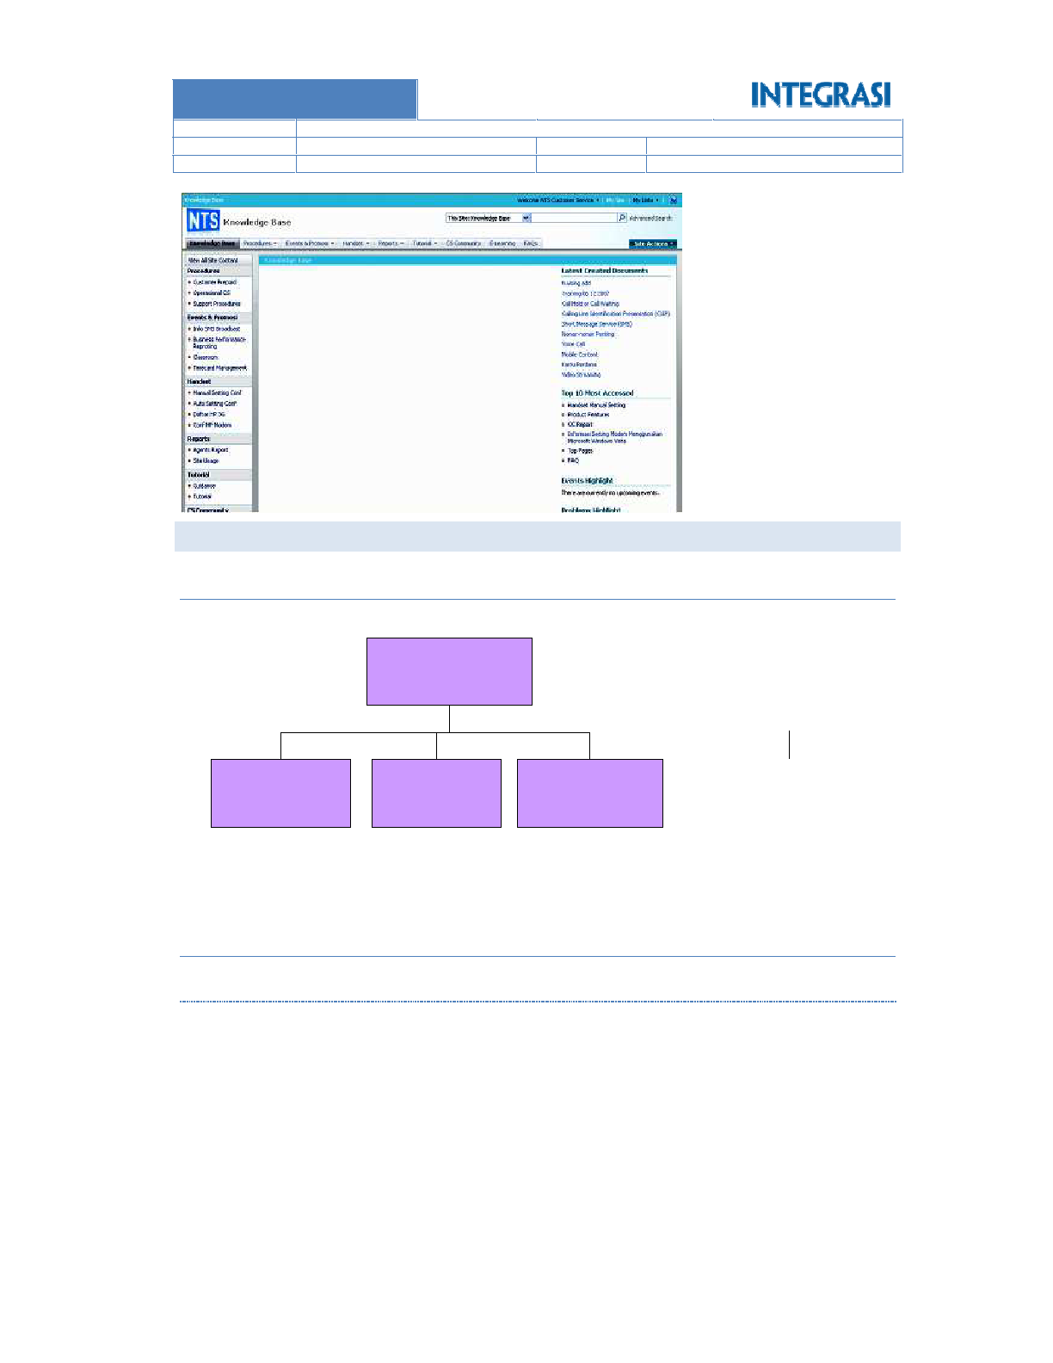

Page **43** of **48**

Enhance ERP System for Manufacturing

ERP System

PDA Golf System

Point of Sales System

Inventory Controling System

:

: Project Manager

: Ricardo Alexander











Project Experience

Position

Name

7.3.2.1 Project Manager

Curriculum Vitae Of Project Leader

7.3.2

Liza Marina

**Technical Writer**

Sonny Ariyadi

**Developer**

Cokky Turnip

**Project Leader**

Ricardo Alexander

**PM Integrasi**

Project Organization

PROJECT STAFFING

7.3.1

7.3

REVISION 1: FINAL RELEASE

1.0

STATUS

VERSION

CONFIDENTIAL

ARISTEJO

INTRANET PORTAL PROJECT

CLASSIFICATION

AUTHOR

TITLE

**INDONESIA**

**GROUP AJINOMOTO**



Page **44** of **48**

Prepare Engagement (sign-off) administration

Develop Change Management strategy

Plan, organize, and assign resources to accomplish the project

Oversee the time completion of all tasks outlined in the project work plan









7.3.3.1 Project Manager

Job Description

7.3.3

Certificate

: MCTS

Operating System: Microsoft Windows, Linux (Ubuntu)

Office: Microsoft Office, OpenOffice

Database: Microsoft SQL Server, MySQL

Programing: C#, VB.Net, Java

Web Programing: ASP.Net, HTML, CSS, ASP, PHP

Microsoft Sharepoint Server 2007, Microsoft Dyanamic CRM 3.0













Technology Skill

:

: Project Leader

: Cokky Saut Monang Turnip

:

eLearning System

Aplikasi Listing and Selling

Helpdesk System







Project Experience

Position

Name

7.3.2.2 Project Leader

Active Directory, LINQ, DLINQ, ExtJS, MonoRail (MVC Framework for .NET)

NHibernate, NUnit, Crystal Report, iBatis, Silverlight, ASP.NET AJAX, Microsoft Visual SourceSafe,

Dreamweaver, Freehand, ComponentOne, Developer Express Component, OOP, Design Pattern,

Foundation (WCF), Microsoft Office, Microsoft Infopath, Flash, Adobe Photoshop, Adobe Premiere,

98/XP, Windows Vista, Windows 2000, Windows Server 2003, Lain-lain: Windows Communication

Networking, Router Configuration, Switch Configuration, Proxy Configuration, Operating System: Windows

SSRS,DBMS), Microsoft Access, MySQL, Oracle, Networking: LAN Networking, WAN Networking, WiFi

1.1/2.0/3.5, PHP, Javascript, HTML, XML, J2SE, Database: Microsoft SQL Server 2000/2005/2008 (SSIS,

Borland C/C++, Visual Basic 6, Borland Delphi 6, .NET 1.1/2.0/3.0/3.5 (C#/VB), ASP, ASP.NET

Technology Skill:

Singapore)

Complex CRM Reporting System (Indonesia, Taiwan, China, Dubai, Phillipine, Thailand,

Document Filing Management System

Call Center (Mumbai India)

FA Shared System

Integrated Treasury System

Operating Expense Budget System

Invoice Controlling System















REVISION 1: FINAL RELEASE

1.0

STATUS

VERSION

CONFIDENTIAL

ARISTEJO

INTRANET PORTAL PROJECT

CLASSIFICATION

AUTHOR

TITLE

**INDONESIA**

**GROUP AJINOMOTO**

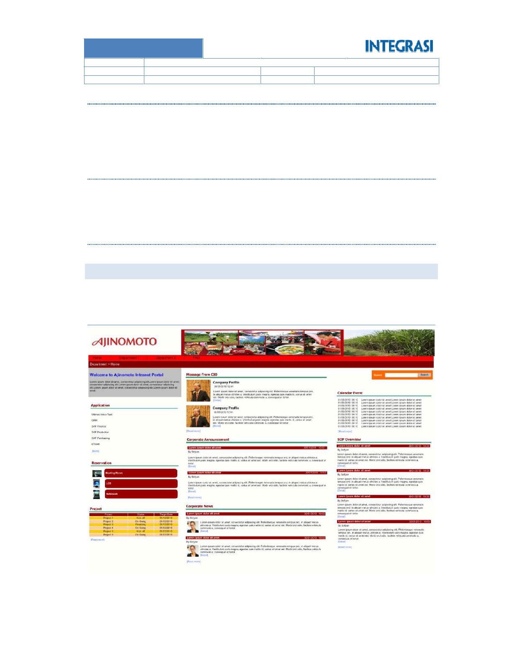

Page **45** of **48**

Corporate Homepage

7.4.1

phase on project.

All screen shots below is only ilustration and not a final design. Final design will be conducted in design

SAMPLE SCREEN SHOTS AND REPORT IMAGES

7.4

Do all the necessary documentation.



7.3.3.4 Technical Writer

Conduct application training

Prepare and execute user acceptance test

Perform physical installation of the application

Customize the application to meet the user requirement









7.3.3.3 Developer

Prepare user acceptance test scenario

Design user interface

Design application and database

Design application specification and functionality (together with client)

Design the solution architecture











7.3.3.2 System Analyst

REVISION 1: FINAL RELEASE

1.0

STATUS

VERSION

CONFIDENTIAL

ARISTEJO

INTRANET PORTAL PROJECT

CLASSIFICATION

AUTHOR

TITLE

**INDONESIA**

**GROUP AJINOMOTO**

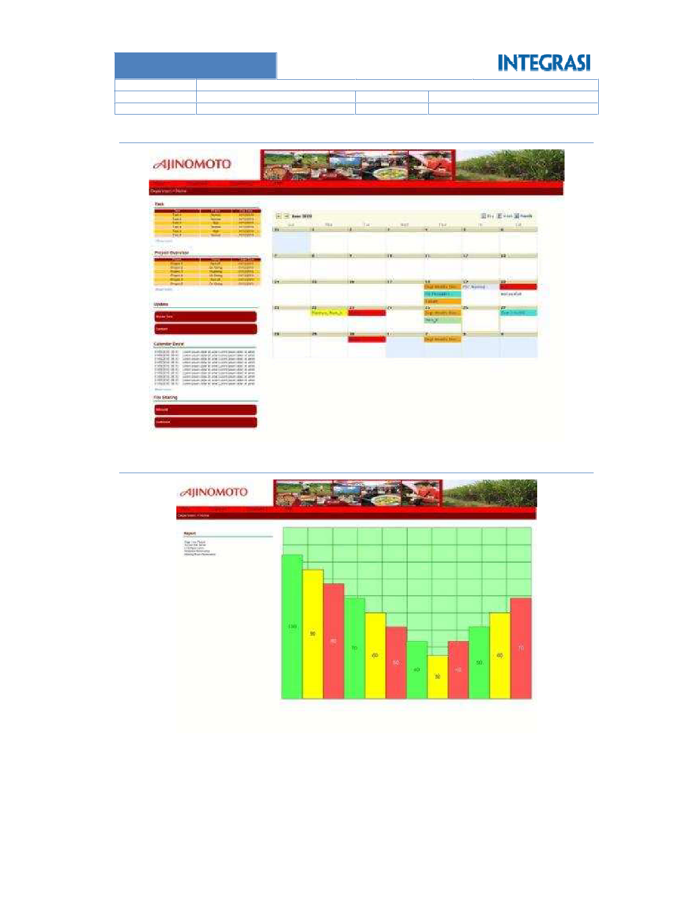

Page **46** of **48**

Report

7.4.3

Department Homepage

7.4.2

REVISION 1: FINAL RELEASE

1.0

STATUS

VERSION

CONFIDENTIAL

ARISTEJO

INTRANET PORTAL PROJECT

CLASSIFICATION

AUTHOR

TITLE

**INDONESIA**

**GROUP AJINOMOTO**

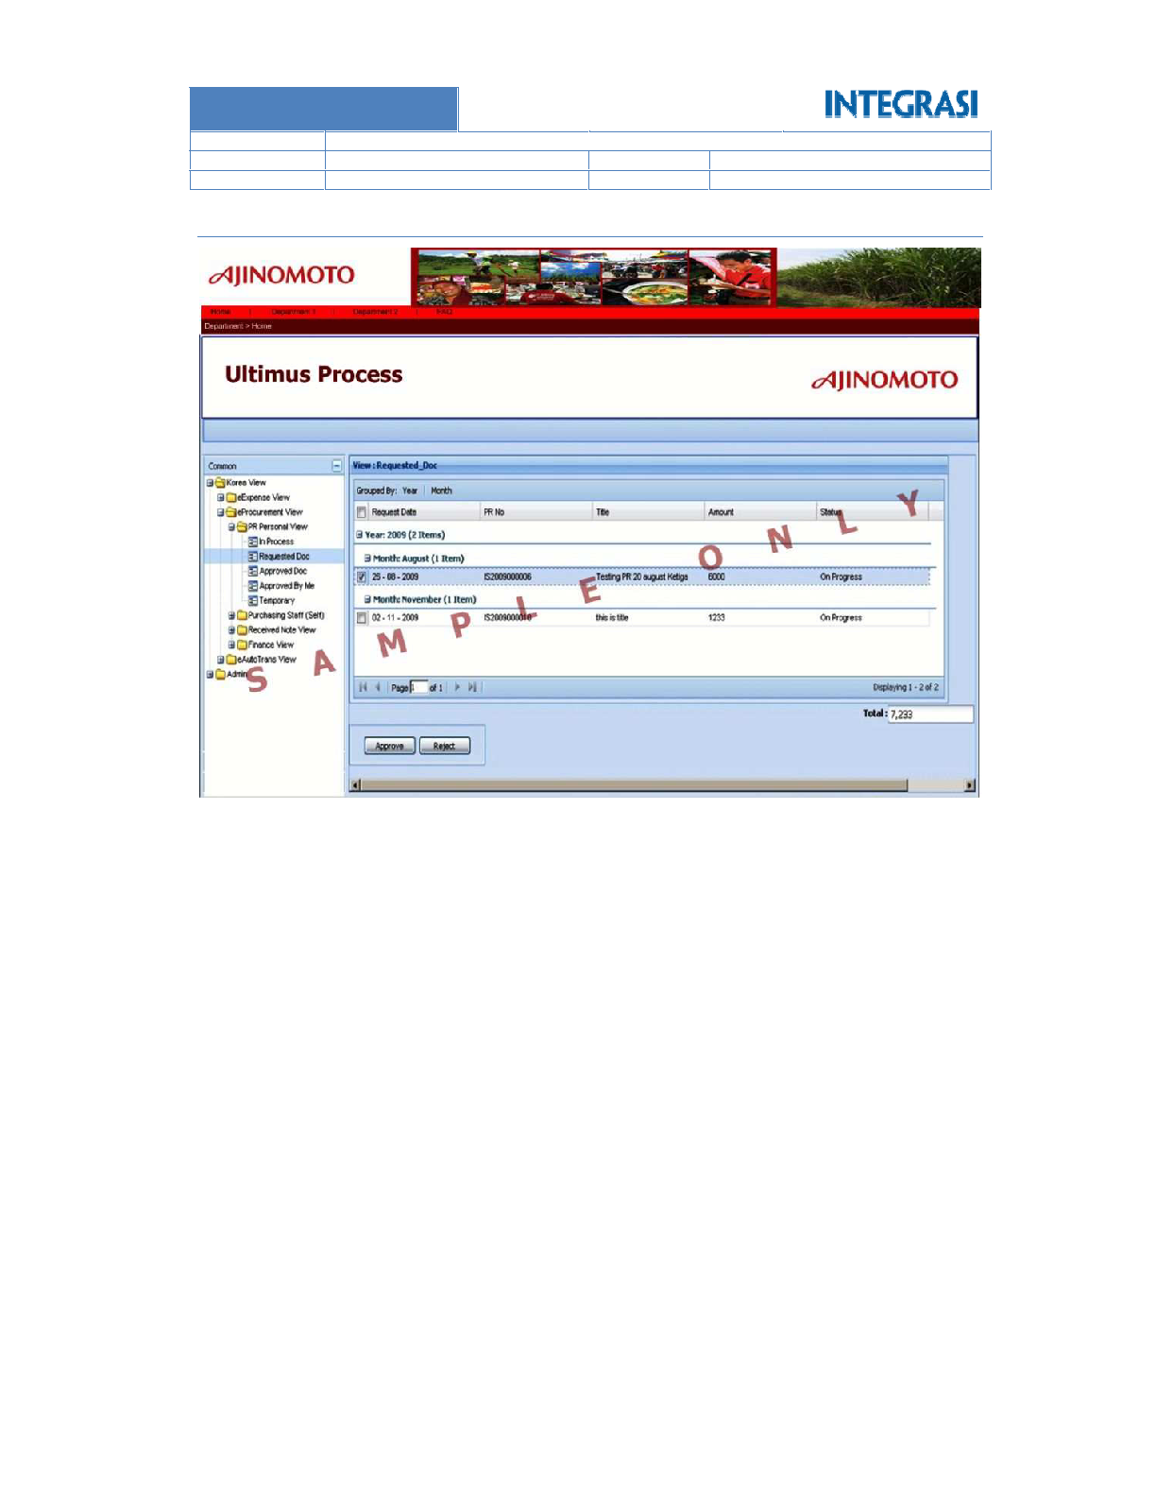

Page **47** of **48**

Integrated with Ultimus Inbox (Future Development)

7.4.4

REVISION 1: FINAL RELEASE

1.0

STATUS

VERSION

CONFIDENTIAL

ARISTEJO

INTRANET PORTAL PROJECT

CLASSIFICATION

AUTHOR

TITLE

**INDONESIA**

**GROUP AJINOMOTO**



Page **48** of **48**







----end of document----

will be signed by both parties (Integrasi Solutions and Group Ajinomoto Indonesia)

Changes to project plan, duration, and cost will be done through Change Request mechanism, which

help Integrasi Solutions when doing the deployment especially with the infrastructure area.

Before deploying the application, Group Ajinomoto Indonesia will assign one or more person to

smooth conduct of training.

access to the course participants to the computer hardware and the application software for the

training would be on the application software developed, Group Ajinomoto Indonesia shall provide

shall provide classroom equipped with Projection system for the conduct of training. Since the

Training shall be conducted at Group Ajinomoto Indonesia premises. Group Ajinomoto Indonesia

request will be determined later.

Solutions and Group Ajinomoto Indonesia. The impact on schedule and cost incurred in this change

scenario out of the scope, it will be treated as a “Change Request” that will be signed both Integrasi

Integrasi Solutions will do all scenarios based on the Scope of Work (SOW) above. If there is a

Integrasi Solutions will develop the application at the office of Integrasi Solutions.

The proposed solution will be in English only and so with the documentation of the project.

SCOPE OF WORKS ASSUMPTIONS







8.3







All modification to existing system will be conducted by Group Ajinomoto Indonesia team’s.

test, etc.

input related to this project such as user requirements, system analysis, system design, acceptance

Group Ajinomoto Indonesia will create a counter team part to support INTEGRASI by giving any

in this project.

Group Ajinomoto Indonesia will give access right such as network, software, and hardware needed

regarding to the project in a reasonable time (should not be more than 1 (one) day).

Ajinomoto Indonesia and Integrasi Solutions. This contact person should be able to make decisions

Group Ajinomoto Indonesia will provide a person who will act as a contact person between Group

Group Ajinomoto Indonesia will provide access to any documentation needed by this project.

RESOURCES ASSUMPTIONS





8.2



Documents signed off both parties will super cede the agreements.

smooth.

team need to be signed by person from both parties to ensure that execution of the project will be

All of business process flow, user interface design and any decision that have been made by project



PROJECT MANAGEMENT ASSUMPTIONS

**ASUMPSIONS**

8.1

**8**

REVISION 1: FINAL RELEASE

1.0

STATUS

VERSION

CONFIDENTIAL

ARISTEJO

INTRANET PORTAL PROJECT

CLASSIFICATION

AUTHOR

TITLE

**INDONESIA**

**GROUP AJINOMOTO**